Greiner Packaging creates packaging solution containing r-PET

Greiner Packaging’s stated aim is to keep plastic circulating in the economy for as long as possible. To this end, the packaging specialists are aiming to work together with their customers to create new packaging solutions that can be recycled themselves or contain recycled material. One recent solution that falls in this category is German food company Jütro’s range of ketchup and sauces bottles, which are partly made from r-PET.

Kremsmünster, Austria (September, 2019) – Sustainability plays an increasingly important role in the packaging industry. And it’s not only consumers demanding packaging that can be easily recycled or is produced in an environmentally friendly way – businesses are also aware of their responsibility to society. As a result, they are opting for solutions such as plastic packaging made in part from recycled materials. For instance, German food company Jütro has put sustainability at the heart of its packaging redesign and now markets 500-milliliter ketchup and sauces bottles made with 30 percent r-PET.

Careful use of raw materials
The squeeze bottles are produced by Greiner Packaging, a longstanding partner to Jütro. “In switching to r-PET for our bottles, we’re helping to ensure that the available raw material resources are used sustainably,” stresses Peter Rothmann, Managing Director of Jütro. “Greiner Packaging is a partner that has extensive expertise in this area – and has given us professional support since day one. As a result, we were able to open up close lines of communication with our contacts in the retail sector.”

r-PET aces the test
To demonstrate the quality of r-PET, all the necessary proof of compliance and bottle samples were presented to Jütro right from the outset. In addition, a collaboration was formed with Austrian firm Erema – a recycling systems specialist – to facilitate in-depth knowledge sharing.

Packaging facts:

- Technology: Injection stretch blow molding
- Decoration: Label
- Capacity: 500 ml
- Materials: PET, r-PET (30%)

About Greiner Packaging
Greiner Packaging is a leading European manufacturer of plastic packaging in the food and nonfood sectors. The company has enjoyed a reputation for outstanding solutions expertise in the fields of development, design, production, and decoration for nearly 60 years. Greiner Packaging responds to the challenges of the market with two business units: Packaging and Assistec. While the Packaging unit stands for innovative packaging solutions, the Assistec unit focuses on producing custom-made technical parts. Greiner Packaging employs a workforce of around 4,800 at more than 30 locations in 19 countries around the world. In 2018, the company generated annual sales revenues of EUR 673 million (including joint ventures), which represents more than one third of Greiner’s total sales.

Text and image:

Text document and high-resolution images for download:
https://mam.greiner.at/pinaccess/showpin.do?pinCode=Yq5PHMG8A80K

Images for royalty-free use (credit: Greiner Packaging International)

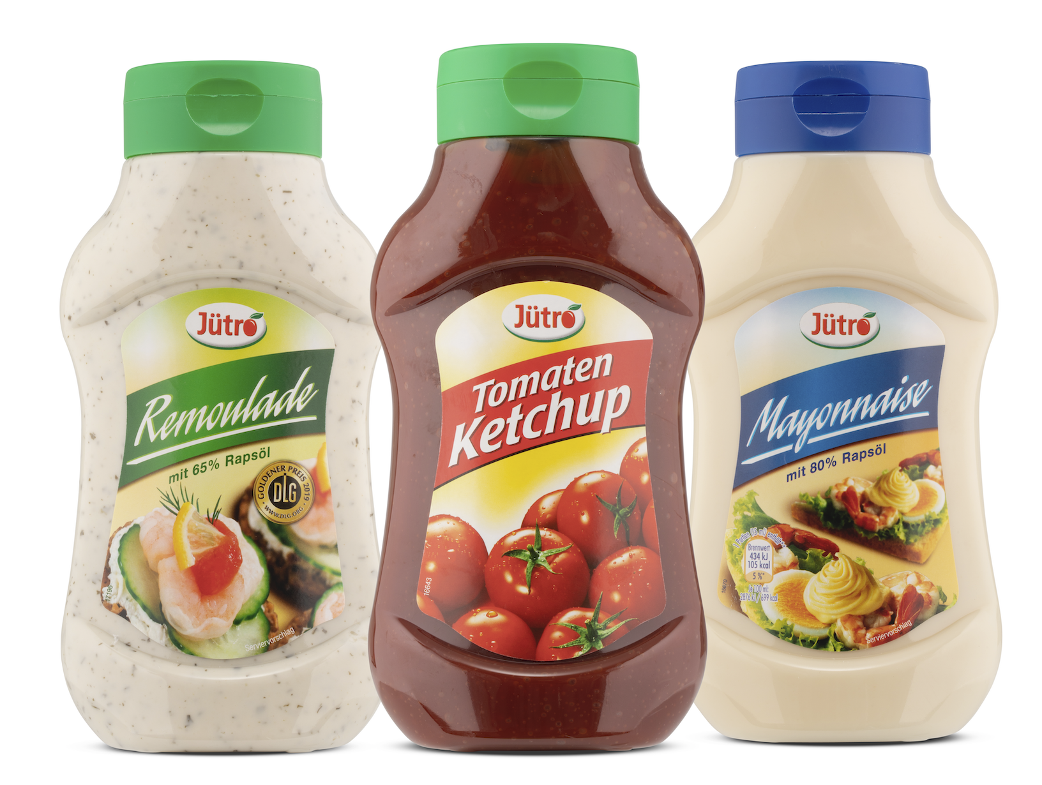

Caption: The new Jütro bottles for ketchup and sauces are made of 30 percent r-PET. They are produced by Greiner Packaging.

Please direct any questions to:
Carina Maurer I Text, Design, Concept, and PR
SPS MARKETING GmbH | B 2 Businessclass | Linz, Stuttgart
Jaxstrasse 2–4, 4020 Linz, Austria
Tel. +43 (0) 732 60 50 38-29
E-mail: c.maurer@sps-marketing.com
www.sps-marketing.com

