Innovative detergent packaging solution: Greiner Packaging receives the Henkel Sustainability Award

Thanks to novel two-chamber technology, Henkel’s Duo-Caps and Power-Mix Caps detergents ensure stain removal, vibrant colors, and freshness with just one cap. The attractive packaging was created by Greiner Packaging. Now, the plastics experts have received the Henkel Sustainability Award for their design in Orlando, Florida.

Kremsmünster, January, 2019. The Duo-Caps and Power-Mix Caps are completely water-soluble, ensuring perfectly clean laundry at temperatures as low as 20°C/68°F – their two separate chambers allow different washing gels or liquid and powder detergents to be combined. Originally marketed in transparent plastic containers, the packaging was changed over to opaque containers in 2014. To retain an attractive appearance, Henkel opted for an alternative packaging solution from Greiner Packaging: K3®-F – a cardboard-plastic combination – is a winner, not only for its appealing design, but also for its reduced plastic content. Now, the plastics experts have been recognized for their innovative approach at the annual conference of the American Cleaning Institute at which Henkel has given out prizes for outstanding supplier performance since 2007. “We have presented Greiner Packaging with the award for Special Contribution to Packaging Development and Project Management. Compared to the previous packaging, the K3®-F boxes help us reduce our plastic consumption by more than 40 percent,” says Arndt Scheidgen, Head of Advanced Technologies at Henkel Laundry & Home Care, commenting on the panel’s decision.

K3®-F: One package, many advantages
Packaging made of cardboard-plastic combinations has enjoyed great popularity in the food sector for many years. Equipped with a special folding wrap, K3®-F is the ideal packaging solution for Henkel’s Duo-Caps and Power-Mix Caps. Thanks to the innovative, patented tear-off system, the cardboard wrap and plastic container can be easily separated and recycled. The packaging’s plastic content is significantly reduced, while the cardboard wrap maintains the container’s stability. The cardboard finish offers consumers a pleasant feel and, printed with an attractive design, commands attention on the shelf. Henkel markets its Duo-Caps and Power-Mix Caps detergents under more than ten different brand names, including Persil, in over 25 countries. The plastic containers and folded cardboard wraps are delivered to Henkel separately. This way, inventories are kept to a minimum despite myriad decoration variants. K3®-F solutions are perfect for such applications.

A solution that’s easy on the environment
“Boasting an attractive wrap-around decoration, our packaging solution is exactly what our customer is looking for. By switching to K3®-F packaging, Henkel has been able to bring 100-percent recyclable packaging onto the market – cardboard wraps and containers can be easily separated and disposed of,” points out Michael Frick, Global Key Account Director at Greiner Packaging. Sustainability is important to the project partners – both Greiner Packaging and Henkel are signatories to the New Plastics Economy Global Commitment launched by the British Ellen MacArthur Foundation. The initiative aims to eliminate problematic or unnecessary plastic packaging, to make packaging reusable, recyclable, or compostable, and to increase the use of recycled materials in packaging. The new packaging has been on the market in Western and Eastern Europe since 2017.

Packaging facts:
- Material: PP
- Technology: Thermoforming
- Decoration: Cardboard wrap

About Greiner Packaging
Greiner Packaging is a leading European manufacturer of plastic packaging in the food and nonfood sector. For almost 60 years, the company has enjoyed a reputation for its great expertise in providing solutions in the fields of development, design, production, and decoration. Greiner Packaging addresses the challenges of the market with two business units: Packaging and Assistec. Greiner Packaging employs a workforce of around 4,800 at more than 30 locations in 19 countries worldwide. In 2017, the company achieved annual sales revenues of EUR 641 million (including joint ventures). This represents more than one third of Greiner’s total revenue.

Text & image:

Text document and high-resolution images for download:
https://mam.greiner.at/pinaccess/showpin.do?pinCode=TfABpK4Feo2H

Images for free use, credit: Greiner Packaging International

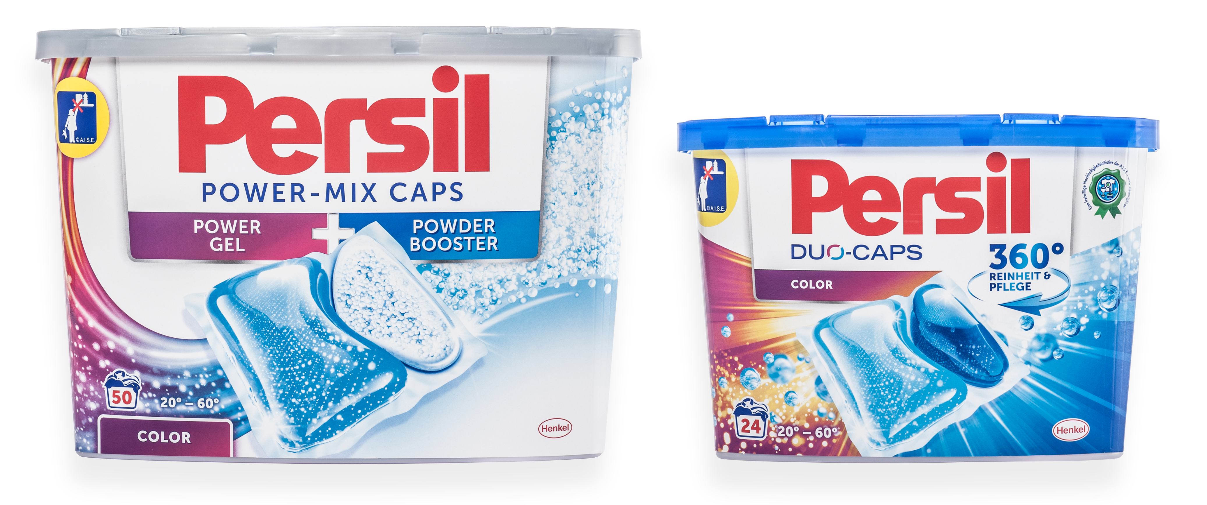
Image text:

Image 1: Using K3®-F, Greiner Packaging creates reduced-plastic packaging for Henkel’s Duo-Caps and Power-Mix Caps detergents.

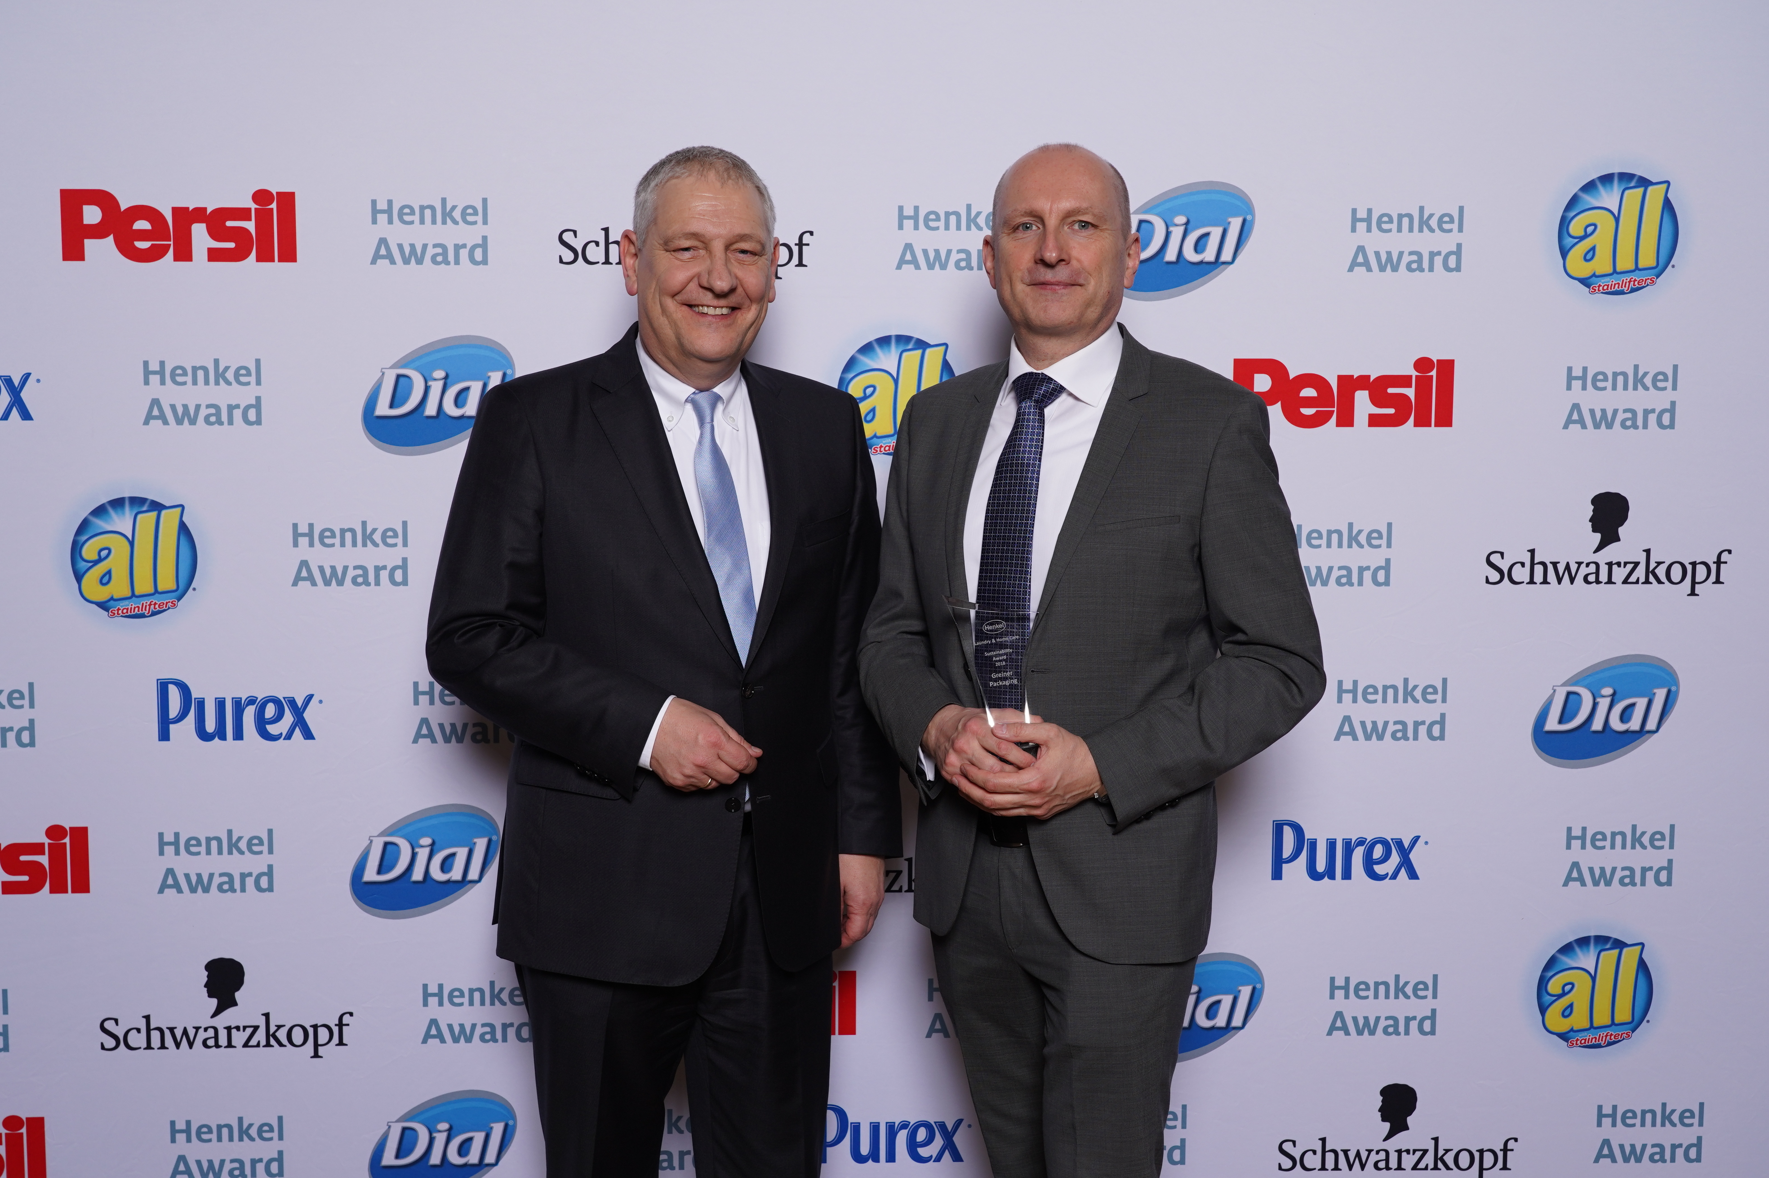

Image 2: The plastics experts have now been recognized for their innovative solution. In Orlando, Michael Frick, Global Key Account Director at Greiner Packaging, accepted the Henkel Sustainability Award in person.

Left: Thomas Müller-Kirschbaum (Corporate Senior Vice President R&D Laundry & Home Care and Co-Chair of Henkel‘s Sustainability Council), right: Michael Frick (Global Key Account Director at Greiner Packaging)

Please direct any questions to:
Ms. Carina Maurer I Text, Design, and PR
SPS MARKETING GmbH | B 2 Businessclass | Linz, Stuttgart
Jaxstrasse 2–4, 4020 Linz, Austria
Tel.: +43 (0) 732 60 50 38-29
E-mail: c.maurer@sps-marketing.com
www.sps-marketing.com

