K3®-F: Cardboard-plastic packaging conquers new markets

Whether yogurt, cream cheese, or muesli packaging, the K3® cardboard-plastic combinations from Greiner Packaging have been very popular for years. The K3®-F, equipped with a special folding wrap, is now catching a lot of attention in other branches as well. The solution not only meets environmental and design demands, but also helps reduce inventory to a minimum.

Kremsmünster, March 2018. K3®, the cardboard-plastic combination from Greiner Packaging, is attracting attention on the shelves by combining high-quality packaging with appealing marketing communication and environmental protection. Its innovative, patented tear-off system makes it easy to separate the cardboard wrap and plastic cap or container in K3® packaging and recycle them. The low proportion of plastic in the packaging means reduced CO₂ emissions, while retaining the stability of the container through the cardboard wrap. The cardboard surface offers consumers a pleasant feel, and can moreover be attractively printed on and decorated; this gives it an unmistakably distinctive look. Marketing messages can be integrated into the design of the wrap on the interior as well as exterior, and punched windows or special embossed printing can likewise be added, depending on customer requirements.

K3®-F: Separate storage, minimized costs
With K3®-F packaging, customers receive the plastic containers and folded cardboard wrap separately, and the wrap is not mechanically folded and placed over the containers until just before filling takes place. K3®-F is especially suitable for customers who offer their product in various markets or under different brands, and can then use a variety of decorations. This consequently reduces inventory to a minimum. The sustainable packaging solution is suitable for food in powder form, such as cocoa or salt, but it can also replace round or bag packaging types such as those used for pet food. Moreover, K3®-F packaging can replace coated packaging solutions, such as those used for detergents, or cardboard packaging in cereals, for example, in which an additional plastic package is integrated.

Complete solution from Greiner Packaging
Whether round or square, injection-molded or thermoformed container – K3®-F packaging can be implemented for any customer requirement. As a complete solution provider, Greiner Packaging offers plastic containers as well as cardboard wraps and lid solutions (childproof, upon request).

Successful collaboration with Henkel
The collaboration between Greiner Packaging and Henkel is an excellent example of the successful implementation of K3®-F packaging: The original packaging for Duo-Caps and Power-Mix Caps started in transparent plastic containers and was changed to opaque containers in 2015. To ensure an appealing appearance, Henkel decided on an alternative packaging solution: K3®-F, which hits the mark not just with an attractive design, but also helps save plastic. With K3®-F Henkel is able to achieve a 100% recyclable packaging when separating carton from plastic.

Packaging facts:
- Material: PP
- Technology: Thermoforming
- Decoration: Cardboard wrap

About Greiner Packaging
Greiner Packaging is one of Europe’s leading manufacturers of plastic packaging in the Food and Non-Food sector. The company has been known for nearly 60 years for its great skill in providing development, design, production, and decoration solutions. Greiner Packaging faces the challenges with two business units: Packaging and Assistec. Greiner Packaging employs around 4,400 employees at more than 30 locations in 19 countries worldwide. The company achieved annual sales of EUR 581 million in 2016 (including joint ventures). This represents more than one third of the total sales of the Greiner Group.

Text and photo:
The text file as well as high-resolution photos can be downloaded from:
https://mam.greiner.at/pinaccess/showpin.do?pinCode=5kqp90pAysZO

Copyright-free photos, Credit: Greiner Packaging International
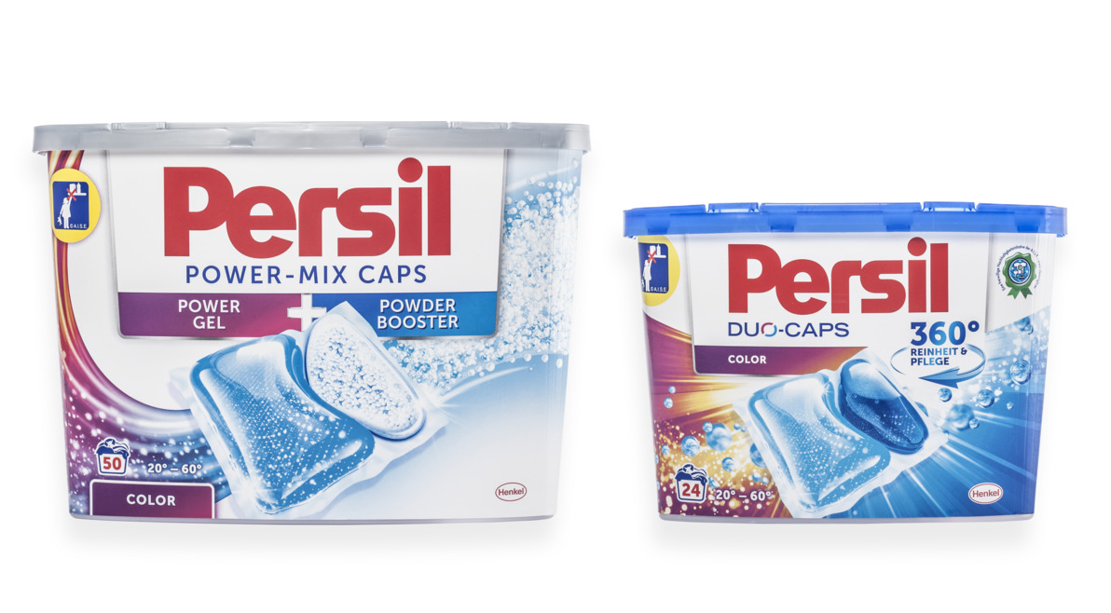
Photo caption: Sustainable, practical, attractive: Henkel has opted for K3®-F packaging from Greiner Packaging for its detergent Duo-Caps and Power-Mix Caps.

For inquiries, please contact:
Mag. Carina Maurer, Bacc. I Text, concept & PR
SPS MARKETING GmbH | B 2 Businessclass | Linz, Stuttgart
Jaxstraße 2 – 4, A-4020 Linz, Austria
Phone: +43 (0) 732 60 50 38-29
Email: c.maurer@sps-marketing.com
www.sps-marketing.com

