Closing the recycling loop: Sustainable cardboard-plastic packaging produced for Henkel by Greiner Packaging now contains 50 % postconsumer recycled PP

Cardboard-plastic combinations as sustainable packaging choice are helping to reduce plastic consumption, while at the same time ensuring high-quality appearance and stability. Henkel’s Persil 4in1 DISCS detergent packaging, which is produced by Greiner Packaging, is a top example. And this is now even more sustainable, as it contains 50 % recycled polypropylene (r-PP) obtained from discarded household plastics, meaning that postconsumer waste is being reused.

Kremsmünster, Austria, April 2020. K3®, the cardboard-plastic combination from Greiner Packaging, combines high-quality packaging with appealing marketing communication and a positive environmental contribution. Henkel uses these sustainable containers to package various detergent capsule products, including its Persil 4in1 DISCS. Thanks to their four individual chambers, the discs ensure the very best washing performance and deep cleanliness with stain removal, ultimate brightness, care for fibers and long-lasting fresh scent. They offer the perfect solution for every laundry challenge with just one optimally pre-dosed product in a modern design. And this is where K3®-F packaging products from Greiner Packaging come into play. The cardboard-plastic combination helped to reduce the use of plastic – by more than 40 % as compared with the previous packaging. The packaging solution also received a Henkel Sustainability Award in January 2019 in recognition of these qualities.

Enhanced environmental contribution thanks to recycled material
Thanks to its innovative, patented tear-off system, the cardboard wrap and the plastic container can be easily separated and recycled. Because the two components can be disposed of separately, the consumer benefits from packaging that is 100 % recyclable. The packaging’s lower plastic content helps to reduce CO₂ emissions, while the cardboard wrap maintains the container’s stability.

But from now on, the packaging product will be even more sustainable: First, cardboard with 92 % recycled content is used to make the cardboard sleeve, and second, the container now includes 50 % of the recycled material r-PP. Greiner Packaging uses a two-layer process to create the new design: While the inside of the plastic container is made of white virgin material to guarantee a high-quality appearance and product presentation of the DISCS to consumers, the outer layer of the packaging includes r-PP from postconsumer sources. This layer’s grayish color has no impact on the look of the packaging, because it is encased by the cardboard sleeve that can be printed for an attractive appearance.

Joint efforts for sustainable packaging solutions
“By using r-PP, we’re taking another important step forward in terms of the sustainability of our cardboard-plastic packaging materials. Thanks to our innovative two-layer process, we’re meeting the highest standards of sustainability while also making sure that the packaging’s attractive appearance is retained,” stresses Andreas Auinger, international project manager at Greiner Packaging. Sustainability is important to the project partners – Henkel pursues ambitious packaging targets to help avoid and reduce plastic waste and foster a circular economy. For example, by 2025, Henkel wants to reduce the amount of virgin plastics from fossil sources in its consumer products by 50 %. Both Greiner Packaging and Henkel are signatories to the New Plastics Economy Global Commitment launched by the UK-based Ellen MacArthur Foundation. The initiative aims to eliminate problematic or unnecessary plastic packaging, to make packaging reusable, recyclable, or compostable, and to increase the use of recycled materials in packaging. The new packaging solution fully meets these objectives – the plastic content has been significantly reduced, and the components can be recycled and are easily disposed of by consumers. Plus, the packaging product itself contains a high proportion of recycled material.

Complete solution from Greiner Packaging
Whether round or rectangular, an injection-molded or a thermoformed container – any customer requirement can be realized using K3®-F packaging. As a one-stop solution provider, Greiner Packaging supplies both the plastic container and the cardboard wrap as well as lid solutions, which can also be child-resistant if required.

The packaging solution is suitable for powdered foods, such as cocoa, salt, or baby formula, or as a replacement for tube-shaped packaging or pouches like those used for pet food. K3®-F packaging can also serve as a substitute for coated cardboard solutions – as used for detergents – or for cardboard containers integrating additional plastic packaging, such as for cereals.

Packaging facts:
- Material: PP
- Technology: Thermoforming
- Decoration: Cardboard wrap

About Greiner Packaging
Greiner Packaging is a leading European manufacturer of plastic packaging in the food and nonfood sectors. The company has enjoyed a reputation for outstanding solutions expertise in the fields of development, design, production, and decoration for 60 years. Greiner Packaging responds to the challenges of the market with two business units: Packaging and Assistec. While the Packaging unit focuses on innovative packaging solutions, the Assistec unit is dedicated to producing custom-made technical parts. Greiner Packaging employs a workforce of around 4,800 at more than 30 locations in 19 countries around the world. In 2018, the company generated annual sales revenues of EUR 673 million (including joint ventures), which represents more than one-third of Greiner’s total sales.

About Henkel
Henkel operates globally with a well-balanced and diversified portfolio. The company holds leading positions with its three business units in both industrial and consumer businesses thanks to strong brands, innovations and technologies. Henkel Adhesive Technologies is the global leader in the adhesives market – across all industry segments worldwide. In its Laundry & Home Care and Beauty Care businesses, Henkel holds leading positions in many markets and categories around the world. Founded in 1876, Henkel looks back on more than 140 years of success. In 2019, Henkel reported sales of around 20 billion euros and adjusted operating profit of around 3.2 billion euros. Henkel employs around 52,000 people globally – a passionate and highly diverse team, united by a strong company culture, a common purpose to create sustainable value, and shared values. As a recognized leader in sustainability, Henkel holds top positions in many international indices and rankings. Henkel’s preferred shares are listed in the German stock index DAX. For more information, please visit www.henkel.com

Text and image:

Text document and high-resolution images for download:
https://mam.greiner.at/pinaccess/showpin.do?pinCode=hpG3VZql6Pm0

Image for royalty-free use, credit: Henkel

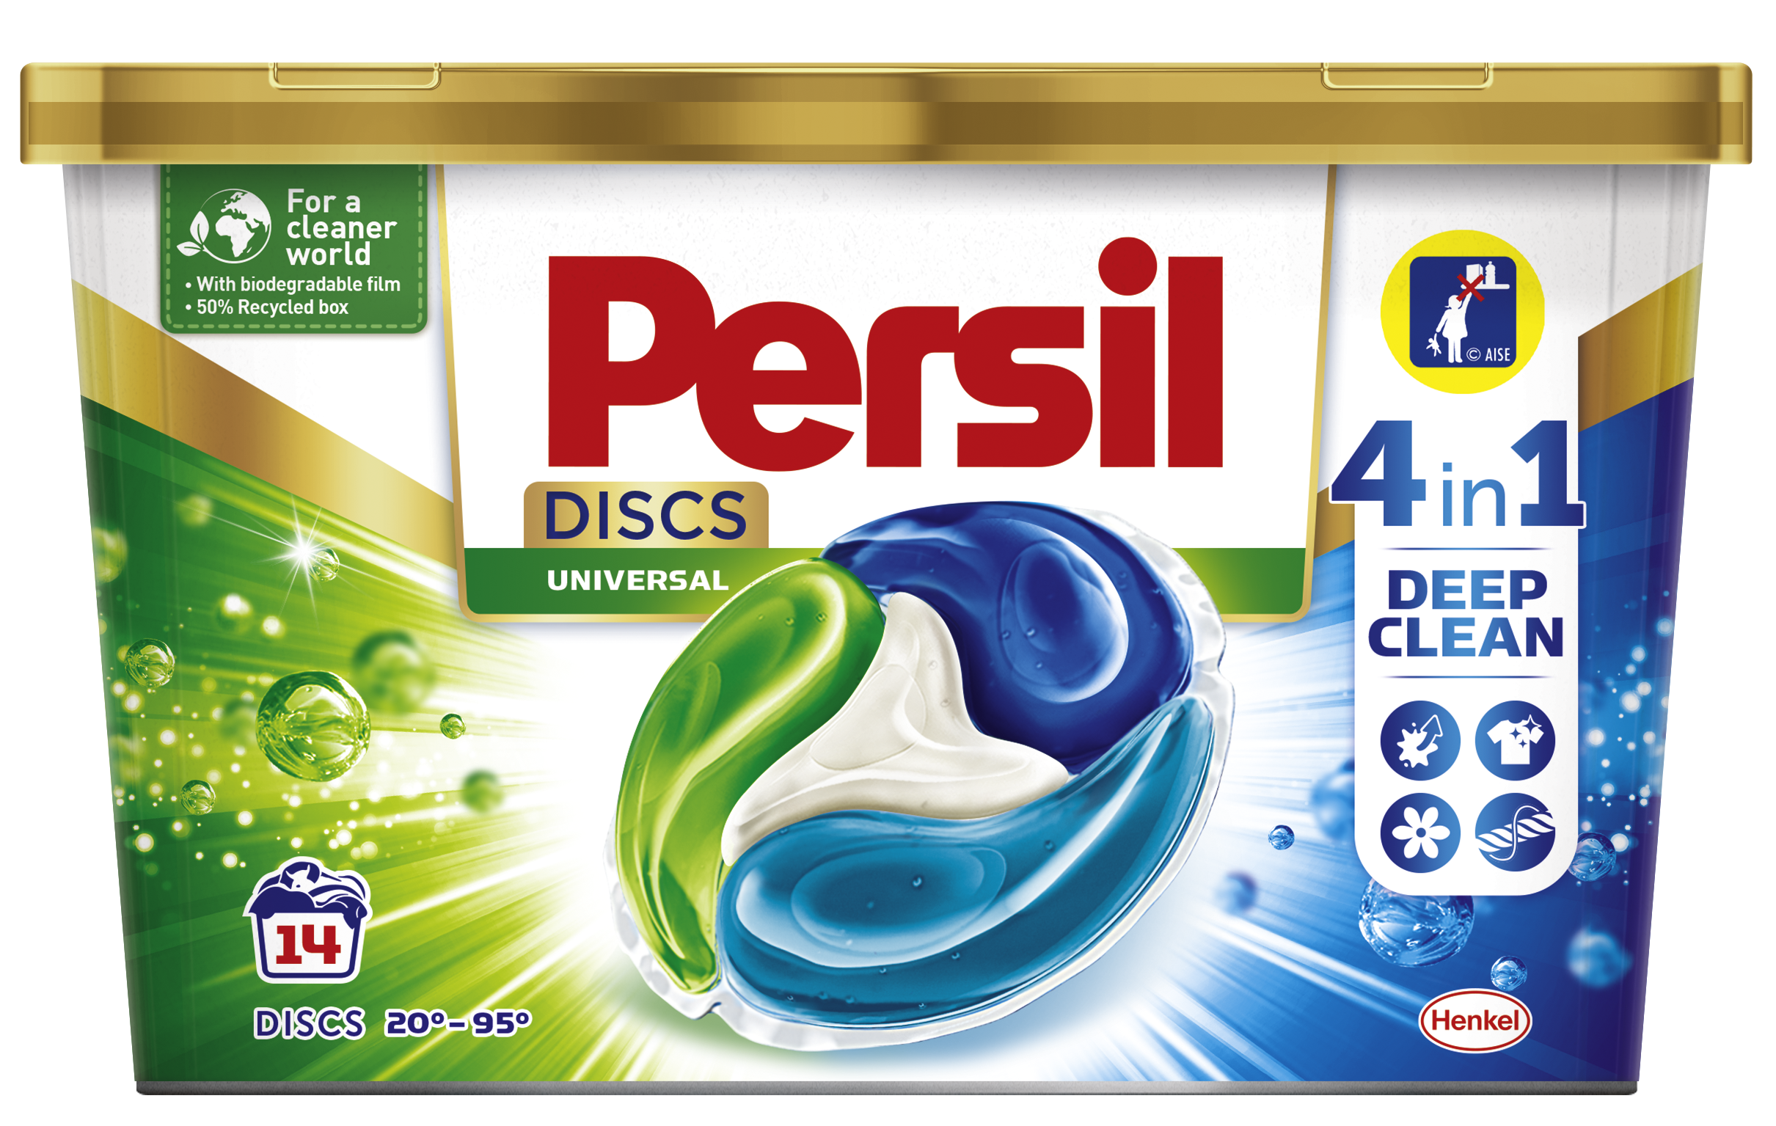

Caption: Detergent packaging produced by Greiner Packaging for Henkel now contains 50 %
r-PP.

Please direct any questions to:
Mag. Roland Kaiblinger I Text, Design, Concept, and PR
SPS MARKETING GmbH | B 2 Businessclass | Linz, Stuttgart
Jaxstrasse 2–4, 4020 Linz, Austria
Tel.: +43 (0) 732 60 50 38-29
E-mail: r.kaiblinger@sps-marketing.com

