Up to 33% material savings with Greiner Packaging’s thermoformed light-weight r-PET K3®

Cardboard-plastic combinations as a sustainable packaging choice are helping to reduce plastic consumption, while at the same time ensuring high-quality appearance and stability. In addition, they offer extended marketing opportunities as the inside of the cardboard wrap can also be printed. Greiner Packaging’s K3® tub saves up to 33% plastic when compared to other pots of the same size, and is made with a minimum of 30% recycled PET (r-PET). The K3® cardboard wrap can be produced with virgin or recycled board produced from sustainably managed forests, with full FSC® (Forest Stewardship Council) chain of custody accreditation.

Dungannon, UK, September 2020. Greiner Packaging’s K3® cardboard-plastic combination, saves up to 33% plastic, while creating eye-catching packaging designed to maximise marketing opportunities.

The K3® light-weight thermoformed tub is made with a minimum of 30% recycled PET (r-PET) –which can be increased to 100% r-PET – and is wrapped with a cardboard outer layer. The K3® pot is a popular lightweight alternative for many dairy brands and has already found its way into the instant snacking and cereal market. The light-weight PET tub uses up to 33% less material than previous IML products. A K3® cup with a diameter of 95 millimeters and a capacity of 500 milliliters achieves a 17% reduction in CO₂ emissions compared with a conventional direct-printed, thermoformed cup of the same size. Meanwhile, the cardboard wrap is produced from either virgin or recycled board – made from sustainable forestry, with full FSC® (Forest Stewardship Council) chain of custody accreditation – and can be decorated with a wide range of finishes.

Shelf impact
Greiner Packaging’s K3® enhances shelf-impact through offering unique shapes and diverse finishing options, with a wide range of cup and tub sizes including the new fridge friendly rectangular pack.

K3® is designed to maximise marketing potential for brand owners, as the cardboard outer can be printed on both sides, creating the opportunity for consumer engagement. While the outside can carrying eye-catching graphics, branding and essential consumer information such as ingredients, the reverse can feature promotions and stickers. There is also an option to create product visibility through the addition of window apertures.

K3® can be completed with a reusable lid which provides a secure seal for the product after it has been opened. The lid extends the product’s shelf-life, preventing it from absorbing odours, and ensuring it does not spill.

“The development of K3® not only enhances a brand’s visibility, but also improves its sustainability credentials,” says Greiner Packaging Product Development Manager Lee McCauley. “Greiner Packaging Switzerland was the original pioneer of the K3® plastic-cardboard packaging solution which has been continuously improved for over 30 years and has been produced in Dungannon since 2013.” Dairy customers were the first to capitalise on its environmental benefits and added-value marketing features, but K3® has now also being widely adopted for the food-on-the-go market with brands such as Symington’s.

Sustainable by design
Thanks to its reduced plastic content, the K3® packaging solution has an improved CO₂ footprint and it can be recycled efficiently, as the cardboard and plastic can be easily separated.

“We are working hard to ensure that K3® is recyclable in every country where it is available, and in the UK, K3® has a ‘good’ recyclability rating,” says UK & Ireland Sales and Marketing Director Julie Eller. Digital watermarks can help to identify K3® products in sorting streams and K3® features an improved tear-off solution for easy separation of materials. The new, patent-pending tear-off system makes separating and recycling the two components clean and intuitive.

“Sustainability is really important to Greiner Packaging. We have joined the Circular Plastics Alliance which aims to boost the EU market for recycled plastics to 10 million tonnes by 2025. We are also proud to have signed up for The Ellen MacArthur Foundation’s New Plastics Economy Global Commitment 2025. We are committed to the concept of a circular economy that keeps plastic in circulation as a material for as long as possible, and have ambitious targets for the use of recycled content. We have pledged to eliminate problematic or unnecessary plastic packaging and to ensure that 100% of plastic packaging we produce should be 100% recyclable, reusable, or compostable.
When the cardboard and plastic parts of K3® are separated, the packaging is 100% recyclable, making it a perfect example of a circular economy product,” Julie Eller adds.

About Greiner Packaging
Greiner Packaging is a leading European manufacturer of plastic packaging in the food and nonfood sectors. The company has enjoyed a reputation for outstanding solutions expertise in the fields of development, design, production, and decoration for 60 years. Greiner Packaging responds to the challenges of the market with two business units: Packaging and Assistec. While the Packaging unit focuses on innovative packaging solutions, the Assistec unit is dedicated to producing custom-made technical parts. Greiner Packaging employs a workforce of around 5,000 at more than 30 locations in 19 countries around the world. In 2019, the company generated annual sales revenues of EUR 690 million (including joint ventures), which represents more than 40 percent of Greiner’s total revenue.

Text and image:

Text document and high-resolution images for download:
https://mam.greiner.at/pinaccess/showpin.do?pinCode=hchhiCE7GRm8

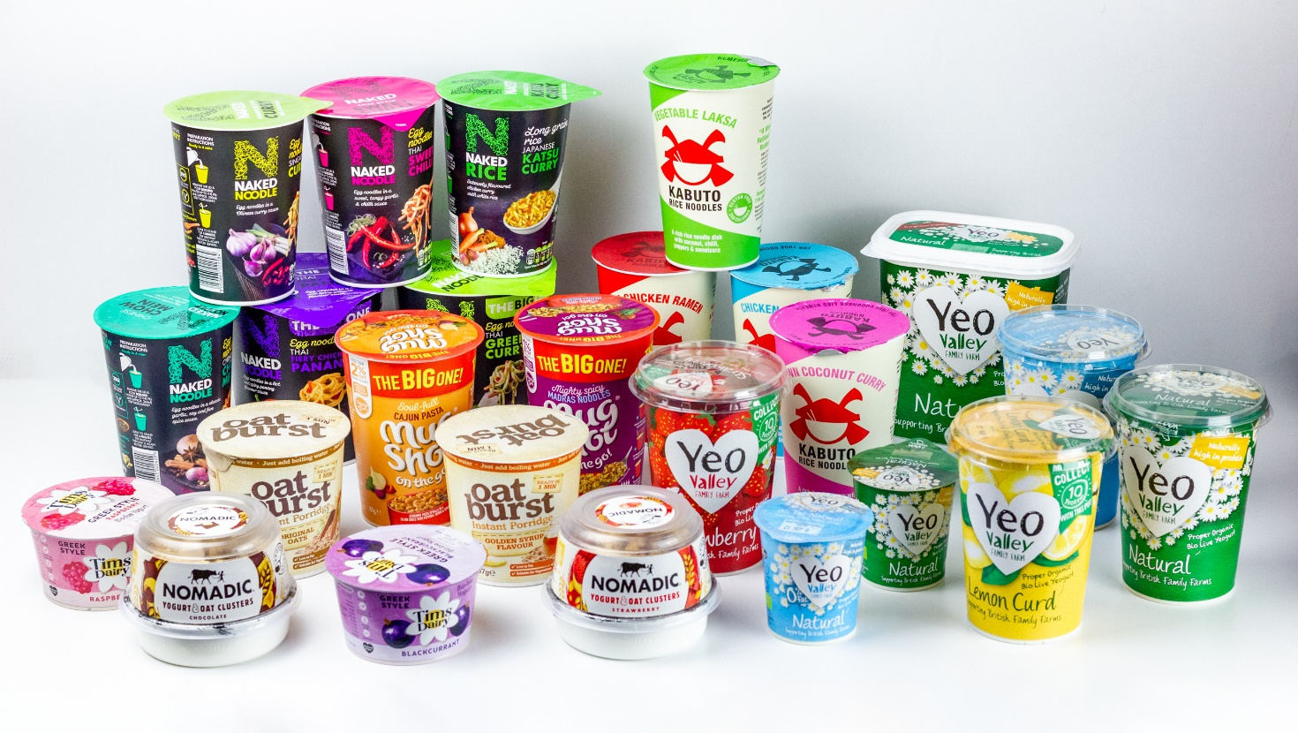

Caption: Greiner Packaging's K3® cardboard-plastic packaging is proving popular for dairy and food-on-the-go brands.

Image for royalty-free use, credit: Greiner Packaging

Packaging facts:
– Material: r-PET or PP for hotfill
– Technology: Thermoforming
– Decoration: Cardboard wrap

Please direct any questions to:
Bill Bruce
Bill Bruce Communications, Swanage BH19 2AA, UK
Tel.: +44 (0)7799 347046
E-mail: bill@billbrucecommunications.com

