Henkel and Greiner Packaging win Green Packaging Award 2020

Henkel and Greiner Packaging have received a special distinction, with their innovative and sustainable packaging solution for Persil 4in1 Discs coming out a winner at the World Packaging Organisation’s Green Packaging Award 2020.

Kremsmünster, Austria, November 2020. The sustainable cardboard-plastic packaging used by Henkel for its Persil 4in1 Discs has been continually upgraded in recent years and is now made from 50 percent postconsumer r-PP. A jointly developed solution, the packaging was a winner at the Green Packaging Award 2020.

“Greiner Packaging has been producing sustainable solutions for many years, and this was a key factor for the award in the Eco-Friendly Company Philosophy category. The new Persil 4in1 Discs packaging solutions are an example of the ongoing collaboration between our companies in this area. So we are delighted to receive this award together with our longstanding customer Henkel,” says Axel Kühner, CEO of Greiner AG.

Sustainable packaging solution
The partners’ ongoing joint development efforts focused on improving the sustainability characteristics of an existing cardboard-plastic solution for premeasured detergent products by using 50 percent postconsumer r-PP. From this perspective, the new K3®-F cardboard-plastic combination is especially impressive because it links high-quality packaging with appealing marketing communication opportunities and a positive environmental impact. This smart combination boasts a lower weight and helps save up to 40 percent more plastic than the previous packaging. Incorporating 50 percent recycled plastic halves the amount of virgin material used. As a result, the 4in1 Discs packaging stands out not just for its sustainability profile but also in terms of its technical functionality.

“We have set ourselves ambitious goals for sustainable packaging and want to promote a circular economy throughout the value chain together with our partners. The use of recycled material plays a key role in this – and the innovative packaging for the Persil 4in1 Discs is a good example of the progress we have already made toward this goal: We use over 90 percent recycled cardboard for the sleeve, and the plastic containers are made from 50 percent r-PP, a recycled material. Production of the new packaging involves a two-stage process. We make the inside of the plastic container from white virgin material, which guarantees a high degree of color contrast with the colorful detergent discs. The packaging’s outer coating, meanwhile, contains recycled plastic obtained from end consumer households. This layer’s gray color does not impact the packaging’s look, because it is wrapped in an attractively printed cardboard sleeve,” explains Eduardo Celada, international packaging manager for laundry care at Henkel.

The sustainable containers for the premeasured detergent products are also more effective in terms of recycling. Thanks to the innovative, patented tear-off system, the cardboard sleeve and plastic container can be easily separated and disposed of on their own by consumers. This makes them 100 percent recyclable. The packaging’s lower plastic content also helps to reduce CO₂ emissions, while the cardboard wrap maintains the container’s stability.

Perfect design solution for global brand owners
The plastic containers and folded cardboard sleeves for the K3®-F packaging are delivered separately to Henkel. The sleeves are only folded by a machine and slipped over the container directly before filling at the company. This process is an excellent fit for global brand manufacturers who offer their product in various markets or under different brands and therefore work with a wide range of decoration solutions. This gives them a high degree of flexibility in terms of the design and keeps stocks to a minimum.

Packaging facts:
- Material: PP
- Technology: Thermoforming
- Decoration: Cardboard sleeve

About Greiner Packaging
Greiner Packaging is a leading European manufacturer of plastic packaging in the food and nonfood sectors. The company has enjoyed a reputation for outstanding solutions expertise in the fields of development, design, production, and decoration for 60 years. Greiner Packaging responds to the challenges of the market with two business units: Packaging and Assistec. While the Packaging unit stands for innovative packaging solutions, the Assistec unit focuses on producing custom-made technical parts. Greiner Packaging employs a workforce of around 5,000 at more than 30 locations in 19 countries around the world. In 2019, the company generated annual sales revenues of EUR 690 million (including joint ventures), which represents more than 40 percent of Greiner’s total sales.

About Henkel
Henkel operates globally with a well-balanced and diversified portfolio. The company holds leading positions with its three business units in both industrial and consumer businesses thanks to strong brands, innovations, and technologies. Henkel Adhesive Technologies is the global leader in the adhesives market – across all industry segments worldwide. In its Laundry & Home Care and Beauty Care businesses, Henkel holds leading positions in many markets and categories around the world. Founded in 1876, Henkel looks back on more than 140 years of success. Henkel generated sales of over EUR 20 billion in the 2019 financial year and recorded an adjusted operating profit of EUR 3.2 billion. Henkel employs more than 52,000 people globally – a passionate and highly diverse team, united by a strong company culture, a common purpose to create sustainable value, and shared values. As a recognized leader in sustainability, Henkel holds top positions in many international indices and rankings. Henkel’s preferred shares are listed on the DAX stock exchange. For further information, see www.henkel.com.

Text and images:

Text document and high-resolution images for download:
https://mam.greiner.at/pinaccess/showpin.do?pinCode=3BqfLSU7luVc

Image for royalty-free use, credit: Greiner Packaging

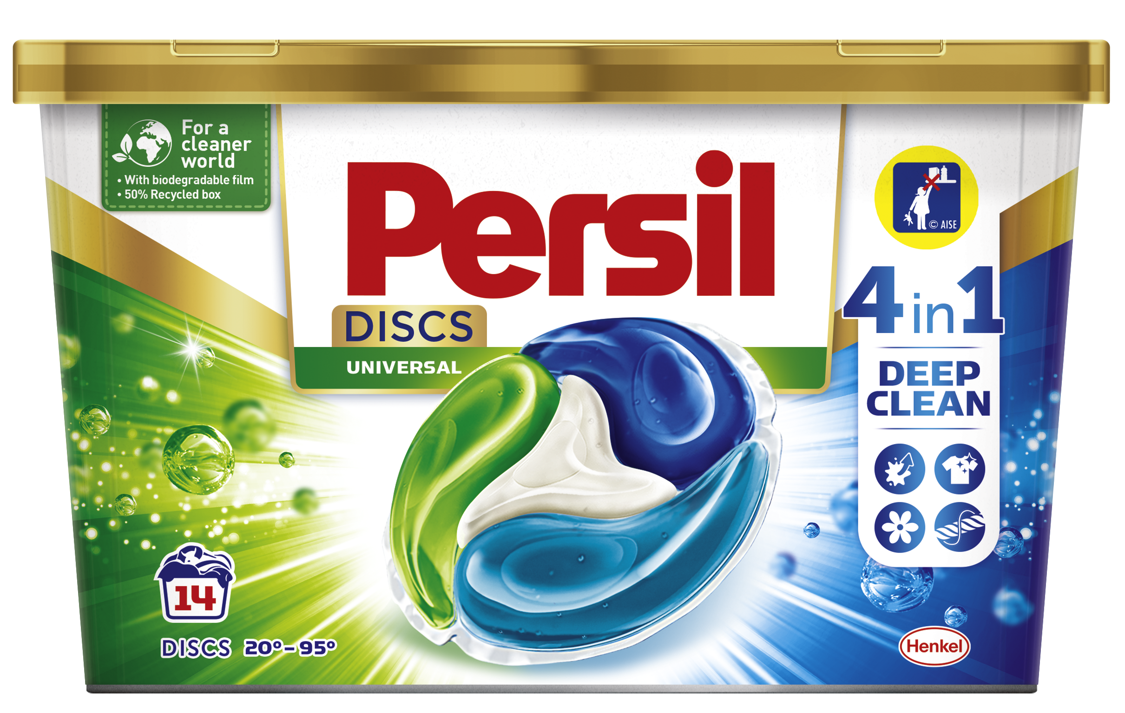

Caption:
Award-winning: The laundry detergent packaging produced for Henkel by Greiner Packaging, now made with 50 percent r-PP.

Image for royalty-free use, credit: Henkel/Richard Tanzer

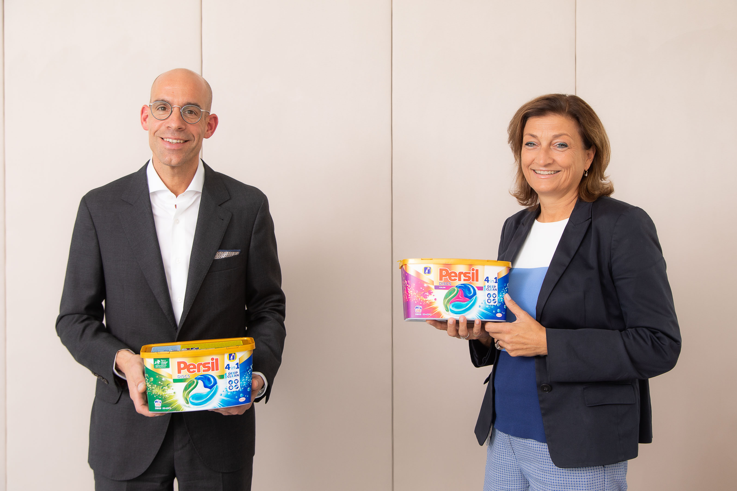

Caption:
Proud winners of the Green Packaging Award 2020 for Persil 4in1 Discs packaging: Axel Kühner, CEO, Greiner AG and Birgit Rechberger-Krammer, Corporate Senior Vice President for Laundry & Home Care in Europe, Henkel.

Please direct any questions to:
Roland Kaiblinger I Account Executive
SPS MARKETING GmbH | B 2 Businessclass | Linz, Stuttgart
Jaxstrasse 2–4, 4020 Linz, Austria
+43 (0) 732 60 50 38-29
r.kaiblinger@sps-marketing.com
www.sps-marketing.com/en

