SalzburgMilch offers a reusable option to single-use plastic lids

For dairy-lovers, being able to grab a spoonful of creamy goodness from the fridge at any time is one of life’s greatest pleasures. And when purchasing your favourite yoghurt or pudding, the largest tub is the most appealing and economical choice. Whether you’re grabbing a sneaky spoonful, or serving up a larger amount, it’s unlikely you’ll be eating 500 g of dairy in one go. A snap-on lid is an absolute necessity.

Kremsmünster, Austria, November 2020. Up until now, all 500 g tubs of SalzburgMilch premium yoghurts, pudding and sour cream have come with fitted with disposable plastic lids. Although they perform the job just fine, these lids generate several tons of plastic waste every year. Taking a huge step towards a sustainable future, SalzburgMilch have recently offered a special promotion. Instead of each 500 g tub coming with a plastic lid of its own, they were topped with high-quality, dishwasher safe, and environmentally friendly reusable lids. The promotional lids look fantastic thanks to in-mold labelling (IML). This means their customers continue to enjoy the same delicious products whenever they like, while generating less waste and contributing to a greener world. ‘We wanted to offer our customers an environmentally friendly and hassle-free alternative. The reusable lids don’t just function well, they look amazing!’ says Prok. Florian Schwap, Marketing Manager at SalzburgMilch. ‘With their own lid conveniently on hand, it’s easy for customers to keep their dairy products fresh at home. There’s no need for each tub to come with its own disposable lid.’

Custom-fit, complete solution
To bring their vision into reality, SalzburgMilch approached Greiner Packaging – a worldwide packaging company with 60 years of experience. Greiner Packaging specialises in resealable packaging options that extend the shelf life of food while enabling it to be handled in a safe and secure way. There are some important factors to consider when designing a reusable lid. Firstly, it needs to be a perfect fit, meaning the seal must be secure so the food is kept fresh. Secondly, it needs to be easy to clean. Greiner Packaging’s multi-use lids are structurally stable, dishwasher safe and maintain their integrity wash after wash. ‘Our multi-use lids can be used over and over again,’ explains Thomas Knoll, Key Account Manager at Greiner Packaging. ‘They’re made from polypropylene (PP) using injection molding and decorated with IML. This combination ensures they’re dishwasher-safe, and when they eventually need to be disposed of, they’re completely recyclable. Less plastic is used overall and more of it is kept in circulation.’

Dishwasher-safe IML labels on the lids
Achieving the perfect label is no easy feat. ‘Greiner Packaging pushed us to our limits,’ reflects Peter Mertens, regional Sales Manager for Central and Eastern Europe at Verstraete IML. ‘They asked us to design IML labels to suit dishwasher-safe lids in both white and super-clear versions. Technologically, this meant aiming extremely high! But we worked together to pull it off. And quite quickly. The product went to market only months after the first idea was floated.’

SalzburgMilch are absolutely delighted with the finished product. Having just launched the promotion in Austria, they’ve received fantastic feedback from regular customers. ‘The lids fit perfectly, and our customers are quite willing to make this change. People are very aware that we need to reduce the amount of plastic we use. Reusable lids offer a wonderful and simple way to contribute to a greener future. The path is now paved for similar sustainable initiatives in the future. And the beautiful design of the lids is like the cherry on top!’ says Prok. Florian Schwap, Marketing Manager at SalzburgMilch.

Packaging facts:

Technology: Injection molding
Decoration IML
Material: PP

About Greiner Packaging
Greiner Packaging is a leading European manufacturer of plastic packaging in the food and nonfood sectors. The company has enjoyed a reputation for outstanding solutions expertise in the fields of development, design, production, and decoration for 60 years. Greiner Packaging responds to the challenges of the market with two business units: Packaging and Assistec. While the Packaging unit stands for innovative packaging solutions, the Assistec unit focuses on producing custom-made technical parts. Greiner Packaging employs a workforce of around 5,000 at more than 30 locations in 19 countries around the world. In 2019, the company generated annual sales revenues of EUR 690 million (including joint ventures), which represents more than 40 percent of Greiner’s total sales.
More information: greiner-gpi.com

About Verstraete IML
Verstraete IML, a part of the Multi-Color Corporation, has over 30 years of experience in off-set printing labels on polypropylene for injection molding, blow molding, and thermoforming. In-depth understanding of materials, advanced research, and quality controls made Verstraete IML a world leader, producing over 60 million in-mold labels every single day for various segments of the plastic packaging industry.
More information: verstraete-iml.com

About SalzburgMilch
As a premium dairy producer, SalzburgMilch sets new standards and assumes responsibility in many ways, especially for the high quality and the pure, rich taste of our new SalzburgMilch Premium products. Sustainability and environmental protection have also been important topics for us for many years. One of the main focuses is on saving plastics in the various food packaging. All SalzburgMilch Premium products are made from ****premium milk which
• meets the high standards of the unique animal health programme
• originates exclusively from regional family farms
• is natural and 100% GMO-free
Try the Premium dairy and cheese products from SalzburgMilch and enjoy their pure, rich taste.
More information: milch.com/de/

Text and image:

Text document and high-resolution images for download:
https://mam.greiner.at/pinaccess/showpin.do?pinCode=82zNNelRgMkr

Image free of charge, credits: Greiner Packaging
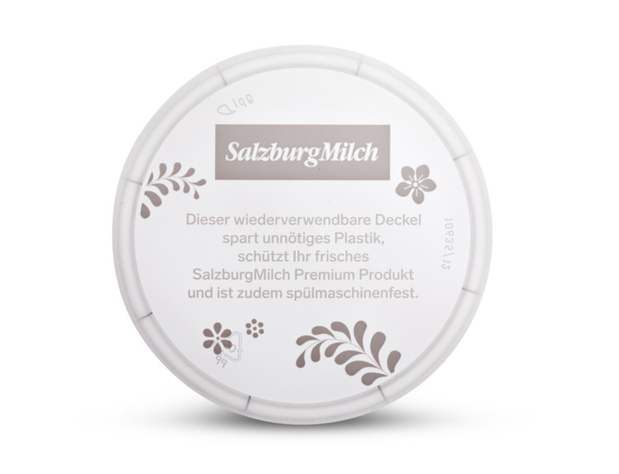
Caption:
A reusable, dishwasher-safe snap-on lid is produced using the injection molding process and can be used on new yogurt cups again and again.

Image free of charge, credits: Salzburg Milch

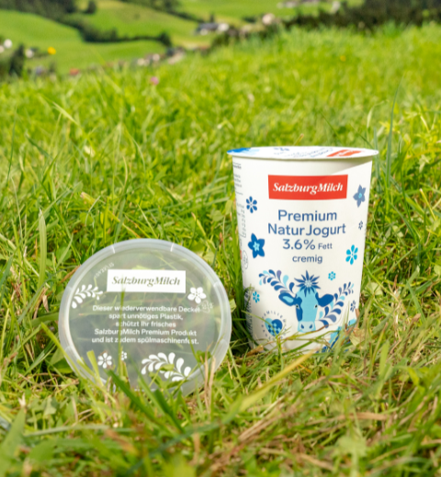

Caption:
Special promotion by SalzburgMilch: Instead of each 500 g tub coming with a plastic lid of its own, they were topped with high-quality, dishwasher safe, and environmentally friendly reusable lids.

Image free of charge, credits: Verstraete in mould labels
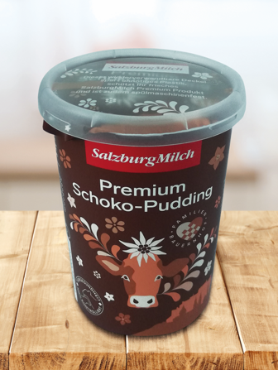
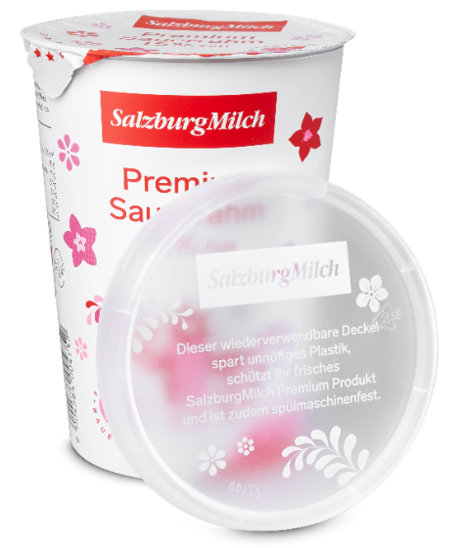

Caption:
Verstraete IML produced labels for white and transparent dishwasher safe lids with a development time of only a few months.

Please direct any questions to:
Roland Kaiblinger I Account Executive
SPS MARKETING GmbH | B 2 Businessclass | Linz, Stuttgart
Jaxstrasse 2–4, 4020 Linz, Austria
+43 (0) 732 60 50 38-19
r.kaiblinger@sps-marketing.com
sps-marketing.com

