Greiner Packaging Innovation Days on June 9 and 10, 2021 – in a virtual event format for the first time

Plastic packaging producer Greiner Packaging is now presenting its product and technology innovations in a new, digital format – as a virtual trade show experience. The event will include keynote speeches, one-on-one meetings, workshops, and live talks with internal and external experts from the packaging sector and beyond. By creating this format, the company is setting new standards for communication with its customers and stakeholders from the industry during this second year of the COVID-19 pandemic.

- First virtual trade show experience by Greiner Packaging
- Engaging presentations and live talks
- Direct, one-on-one conversations with experts
- Focuses on various aspects of sustainability and innovation
- Exciting workshops

Kremsmünster, Austria, May 2021. Greiner Packaging Innovation Days was a popular in-person event in years past, but in 2021, it will be hosted digitally for the first time in the “Virtual Packworld.” This format will give guests a wide range of opportunities to learn about new materials, packaging trends, and innovations as well as giving them first-hand access to expert knowledge.

COVID-19 has changed many things due to the resulting restrictions on interpersonal contact and travel bans, but Greiner Packaging’s innovative spirit has absolutely remained intact. Those attending Innovation Days will now have the chance to experience this for themselves. Rather than hosting an in-person event, Greiner Packaging is responding to the situation by creating a virtual format with digital presentations that will still provide an opportunity for personal interactions and individual networking. “Our way of doing business has been dramatically different for over a year, with in-person business contact reduced to a minimum. By hosting our Innovation Days, we are aiming to highlight just how important professional gatherings are to us. So guests at our event will not only be provided with the very latest information – they will also have the opportunity to actively contribute and make contact with experts from the industry as well as our internal experts from Greiner Packaging,” explains Manfred Stanek, CEO at Greiner Packaging.

Sustainability first
The key topic at this year’s Innovation Days will be sustainability – and how it relates to innovation first and foremost. The entire packaging industry is working to address the exciting challenges
posed by sustainability and innovation these days. After all, the only way to quickly develop eco-friendly solutions is by adopting highly innovative approaches. With this in mind, Innovation Days will focus on factors such as sustainable packaging design, using sustainable materials, improving recyclability, and, of course, the legal aspects pertaining to these efforts.

New, interactive live formats
Engaging keynote speeches and expert talks await guests at this year’s Innovation Days, covering topics including sustainable materials such as r-PS and r-PET HTS as well as new market trends and innovations like digital watermarks, to name just a few examples. After each round of live talks, the relevant experts – including brand owners as well as specialists from NGOs and the waste management and retail sectors – will be on hand to answer any questions. Moreover, visitors can make one-on-one appointments with the experts from Greiner Packaging.

Additional workshops are designed to get virtual guests involved in the event program – with an even more interactive, dynamic approach that offers a closer look at sustainability issues. Greiner Packaging has also created an exciting and engaging way of exhibiting its new product highlights by introducing them in a dedicated area that offers guests a more in-depth look at the innovative world of products offered by the packaging manufacturer.

Plus, all the presentations and expert talks will be available to download from the media library after the virtual event. Starting middle of May, registered guests will be able to create their own program of presentations and conversations for this free event as “My agenda”. This will enable them to prioritise and schedule the most relevant subjects during the live event on June 9 and 10. After the event, they can experience the content of the Innovation Days and Greiner Packaging’s Virtual Packworld at any time, on demand.

Trade show facts:
- Greiner Packaging Innovation Days – virtual trade show experience
- Date: June 9 and 10, 2021
- Location: Virtual Packworld, digital platform to be accessed by registered attendees
- Registration from May 4 at www.packworld-gpi.com/registration
- free admission
- Further information on the program will be available from middle of May at the registration page as well as the event platform

About Greiner Packaging

Greiner Packaging is a leading European manufacturer of plastic packaging in the food and nonfood sectors. The company has enjoyed a reputation for outstanding solutions expertise in the fields of development, design, production, and decoration for more than 60 years. Greiner Packaging responds to the challenges of the market with two business units: Packaging and Assistec. While the Packaging unit focuses on innovative packaging solutions, the Assistec unit is dedicated to producing custom-made technical parts. Greiner Packaging employs a workforce of around 5,000 at more than 30 locations in 19 countries around the world. In 2019, the company generated annual sales revenues of EUR 690 million (including joint ventures), which represents more than 40 percent of Greiner’s total sales.

Text and image: Greiner Packaging, Silvia Wittmann (image Manfred Stanek, CEO Greiner Packaging)

Text document and high-resolution images for download:
https://mam.greiner.at/pinaccess/showpin.do?pinCode=0hEF9DPuQCqc

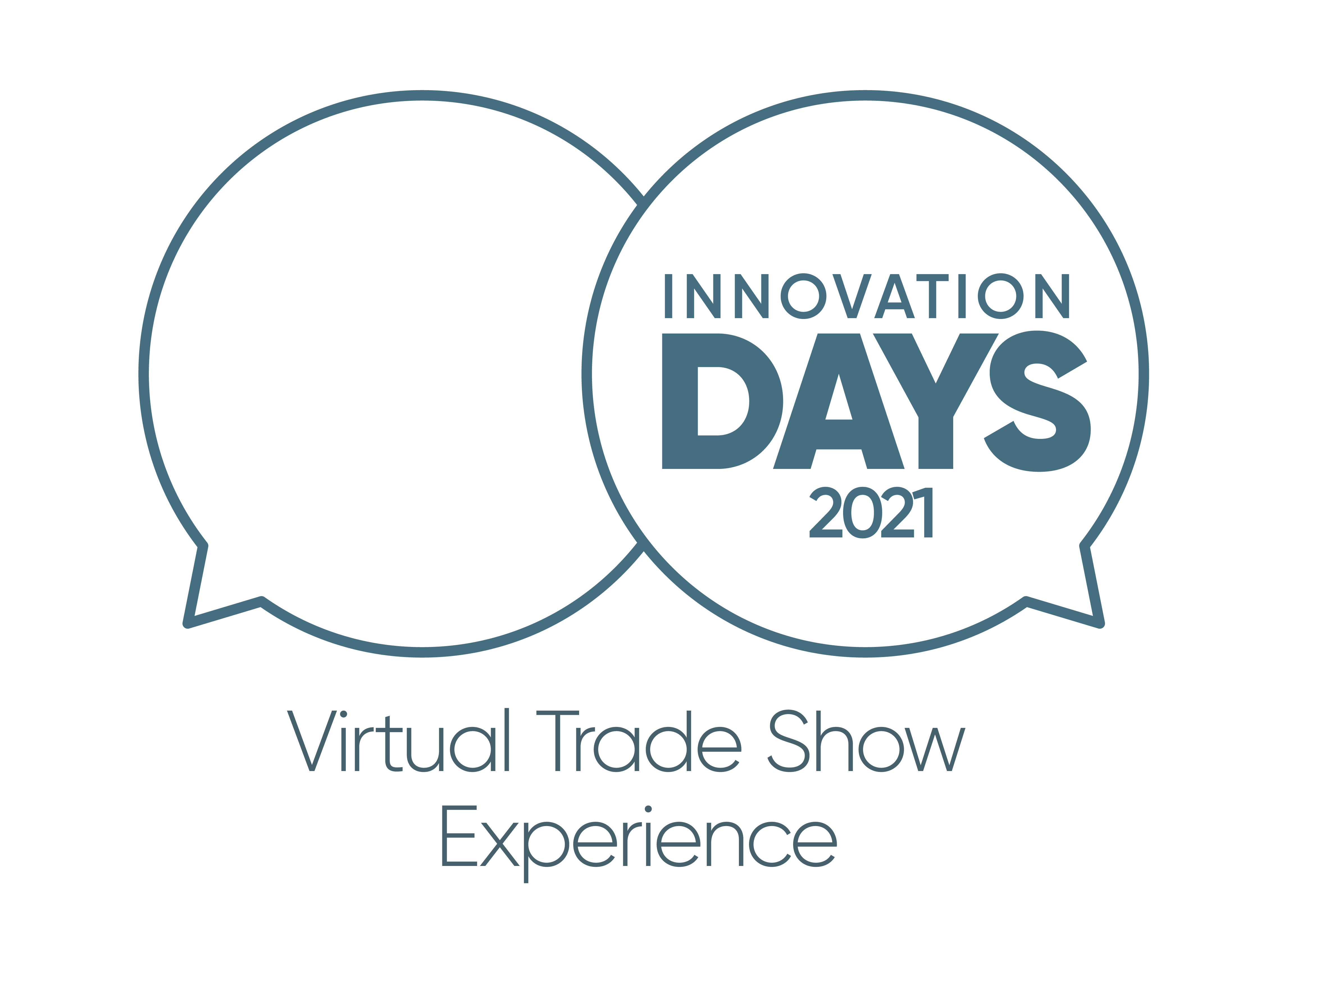

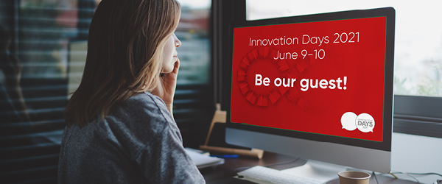

Caption: Greiner Packaging Innovation Days will take the form of a virtual trade show experience for the first time in 2021.

Please direct any questions to:
Roland Kaiblinger I Account Executive
SPS MARKETING GmbH | B 2 Businessclass | Linz, Stuttgart
Jaxstrasse 2–4, 4020 Linz, Austria
Tel. +43 (0) 732 60 50 38-29
E-mail: r.kaiblinger@sps-marketing.com
www.sps-marketing.com/en

