All about innovations – the virtual Greiner Packaging Innovation Days on June 9 and 10, 2021

Product and technology innovations are set to take center stage, especially on the second day of Greiner Packaging’s event, this year hosted by the plastic packaging manufacturer as a virtual trade show experience. Engaging live talks, workshops, and one-on-one meetings will demonstrate that innovation is the key to making a circular economy a reality.

- Strong focus on innovation as an enabler for a circular economy
- The future of packaging solutions is digital
- New technologies and design concepts
- High-caliber keynote speeches and expert-led sessions

Kremsmünster, Austria, June 2021. Due to the pandemic, Greiner Packaging is organizing its Innovation Days as a digital format this year – with a program that offers much to look forward to. While the keynote speeches and sessions on June 9 will primarily focus on sustainability, innovation will take center stage on June 10. Guests will have exciting opportunities to gather information and speak directly with respected experts from the packaging industry and waste management sector, all in the virtual space. In one highlight from the program for day two, Andreas Opelt, COO and member of the executive board at Saubermacher, will be speaking about innovations in waste collection and recycling just before midday. He will look at how the latest technologies and digital transformation are giving rise to sustainable processes and results in this field and how these developments can play a key role in shaping the future of recycling.

Broad program of virtual live talks
On the afternoon of June 10, the virtual Innovation Days event will focus entirely on the significance of innovation for a circular economy. For example, with Jennifer Stanley, founder and managing director of Appetite Creative, and James Males, commercial director at Appetite Creative, the organizers have secured two true specialists to speak on the subject of connected packaging – the integration of intelligent technologies into packaging solutions for products.
Piet de Vriendt, senior business development manager at Kezzler, and John B. Beerens, chief sales officer at Kezzler, will initiate discussions on new approaches to the digital transformation, specifically in the form of cloud-based UIDs (unique identifiers).
Christian Schiller, co-founder of Cirplus, will present new technologies that use digital methods to track streams of recycled materials in a live talk dedicated to this topic. A further session will focus on digital watermarks, a project that Greiner Packaging is pushing forward together with partners such as the Digimarc Corporation and its chief evangelist and speaker Larry Logan. Both companies are also involved in the HolyGrail 2.0 initiative set up by the European Brands Association (AIM). Other live sessions will look at the potential that barrier technologies can open up for a circular economy and design aspects that will determine the way forward for sustainable packaging solutions in the future.

Workshops and meetings with experts
Guests attending either of the Innovation Days will have the opportunity to take part in interactive workshops on the topic of life cycle assessments. They will also have the chance to speak with experts from Greiner Packaging by booking individual one-on-one meetings. Plus, customers will be able to gain insights into the world of Greiner Packaging’s product and design solutions on both days of the event as well as download informative white papers, brochures, and fact sheets provided by the packaging specialists.

For the complete Greiner Packaging Innovation Days program, please visit www.packworld-gpi.com/registration. Guests can use the MyAgenda function to create their own schedule for the event. They will then receive a reminder before the start of every item they have marked on the agenda to make sure they do not miss any sessions. After the digital event, those who have registered in advance will be able to download all of the content from Innovation Days on the platform.

Trade show facts:
- Greiner Packaging Innovation Days – virtual trade show experience
- Dates: June 9 and 10, 2021
- Location: Virtual Packworld, digital platform can be accessed by registered guests
- Registration at www.packworld-gpi.com/registration
- Free admission
- Further details on the Innovation Days program can be found on the registration website and trade show platform

About Greiner Packaging

Greiner Packaging is a leading European manufacturer of plastic packaging in the food and nonfood sectors. The company has enjoyed a reputation for outstanding solutions expertise in the fields of development, design, production, and decoration for more than 60 years. Greiner Packaging responds to the challenges of the market with two business units: Packaging and Assistec. While the Packaging unit focuses on innovative packaging solutions, the Assistec unit is dedicated to producing custom-made technical parts. Greiner Packaging employs a workforce of around 5,000 at more than 30 locations in 19 countries around the world. In 2019, the company generated annual sales revenues of EUR 690 million (including joint ventures), which represents more than 35 percent of Greiner’s total sales.

Text and image: Greiner Packaging, Silvia Wittmann (image: Manfred Stanek, CEO of Greiner Packaging)

Text document and high-resolution images for download:
https://mam.greiner.at/pinaccess/showpin.do?pinCode=8BVrTBLAXQlk

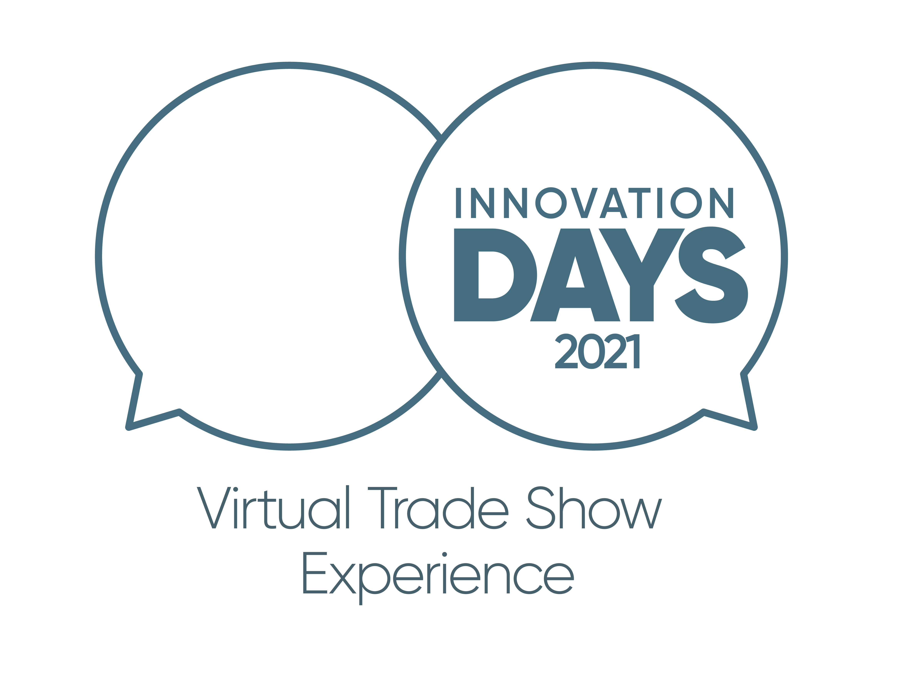

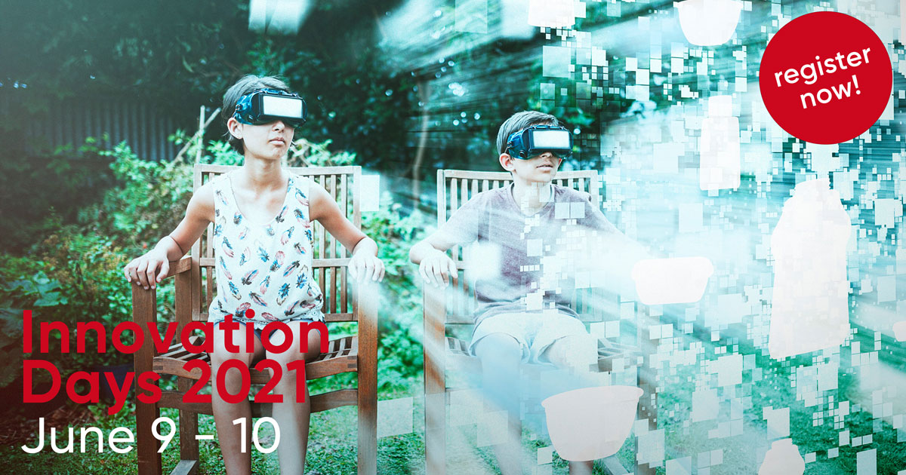

Caption: The Greiner Packaging Innovation Days will feature engaging live talks on sustainability and innovation, workshops, product insights, and much more.

Please direct any questions to:
Roland Kaiblinger I Account Executive
SPS MARKETING GmbH | B 2 Businessclass | Linz, Stuttgart
Jaxstrasse 2–4, 4020 Linz, Austria
Tel.: +43 (0) 732 60 50 38-29
E-mail: r.kaiblinger@sps-marketing.com
www.sps-marketing.com

