FACHPACK 2021: Greiner Packaging to showcase innovative and sustainable packaging concepts for the future

Alternative and recycled materials, barrier technologies, innovative solutions for the POS, and the circular economy itself will be the focus of Greiner Packaging’s appearance at FachPack this year. The packaging experts will be exhibiting in Nuremberg, Germany from September 28 to 30, giving prospective and existing customers an exciting look at current developments, trends, and innovations.

Kremsmünster, Austria (September 2021) – Offering a unique event experience, FACHPACK, the European trade show for packaging, technology, and processing, is an important agenda setter for the European packaging industry and its customers. The expo provides a platform for exhibitors and visitors from every industry to have conversations, inspire one another, and work together on the packaging ideas of the future. Greiner Packaging will also be taking the opportunity to showcase its broad range of products and services at the event. Taking center stage at this year’s exhibit will be the point of sale, barrier solutions for longer food shelf life, and sustainable packaging solutions that meet the criteria associated with a sustainable circular economy. Those interested in visiting but unable to come to Nuremberg due to continuing travel difficulties will still have the opportunity to attend the trade show virtually. Company exhibits and product presentations can be viewed on the myFACHPACK online platform or digital appointments can be made with the Greiner Packaging trade show team.

POS: first impressions count
Packaging is especially important in a retail setting. It acts as an information carrier, plays a product presentation role, and takes on the tasks of brand communication and sales promotion. Anyone looking to stand out from the competition will need to embrace innovative ideas and fresh approaches – both in terms of the design and decoration of the packaging, but also with regard to logistics and presentation. Plus, the digital revolution has now clearly become a factor at the POS. More and more often, digital elements are a popular part of packaging, and these require greater know-how and expertise from specialists such as Greiner Packaging.

Sustainable packaging solutions
Across the board, almost all packaging today has to meet the criteria associated with a sustainable circular economy. With this in mind, Greiner Packaging will be displaying a broad range of different potential solutions at FACHPACK.

From recycled and alternative materials …
By offering a diverse assortment of materials, Greiner Packaging ensures that customers have a choice between not only the most sustainable options but also the best possible solution for each individual project. One category of solutions the packaging specialists will be exhibiting is alternative materials. These are alternatives to conventional plastics that do not require any new concepts in terms of filling or use and can be easily swapped in. An example would be paper cups for the ice cream market. Another range of potential solutions to be showcased at the trade show will be prototypes made from renewable materials. By using the BornewablesTM range, Greiner Packaging has for the first time integrated renewable resources into the production of food cups made from polypropylene (PP) with in-mold labeling (IML) as the decoration technology. The new premium polyolefins come from Borealis.

In addition, Greiner Packaging will be showing attendees a number of recycled materials. By using recycled materials for new packaging, recycling chains can be kept circular in the future. For instance, Greiner Packaging is currently developing prototypes made of r-PET HTS – recycled PET that is suitable for high-temperature sterilization, enabling it to withstand heat and steam. And r-PS, recycled polystyrene, is already used at Greiner Packaging as a drop-in solution for yogurt cups.

When processed, this behaves just like virgin material and does not require any adjustments – plus, the systems remain just as productive. As well as all the environmental and shop-floor advantages of polystyrene, food-quality r-PS offers the additional benefit of being a completely circular polymer with a good environmental footprint.

… through cardboard-plastic combinations …
An innovative improvement to the popular cardboard-plastic combinations will also be presented for the first time at FACHPACK. Consumers were previously asked to separate the cardboard wrap from the plastic cup and then dispose of the two items. But with the new K3® r100, Greiner Packaging has developed a solution in which the cardboard wrap separates itself from the plastic cup during the waste collection process – even before they arrive at the recycling facility. This innovative development makes cardboard-plastic combinations substantially easier to recycle, with the cardboard and plastic assigned to the correct material streams during the initial sorting process before being recycled. And the packaging still features the innovative tear-off solution, which makes separating the plastic and cardboard easier and more intuitive. This means environmentally conscious consumers can continue to separate the items themselves and play it safe when it comes to recycling. It was not for nothing that the tear-off was praised by the jury for the Swiss Packaging Awards, among others.

… to digital watermarks
Digital watermarks, which are being used in initial trials on cardboard-plastic combinations, will also be featured at the show. The codes – which are the size of a postage stamp – are unnoticeable on the packaging surface at first glance. Yet they can still communicate a range of information about the attributes of the packaging, from the manufacturer, the waste management system, the article number, the types of plastic contained, and the composition of multilayer packaging solutions through details regarding the packaging product’s use in the food or nonfood sector. In the future, when used packaging is collected and sent to a sorting system that recognizes the digital watermark, the system will be able to detect and decode it on the sorting belt using a standard high-resolution camera. Depending on the attributes communicated by the watermark, the packaging can then be automatically directed to the right sorting stream, which would allow for more homogeneous streams and higher-quality recycled materials in the future.

Barrier for ideal product protection
In the third major theme of its exhibit, Greiner Packaging will be shedding light on the key issue of sustainability from a different angle: using barrier solutions to extend the shelf life of foods. In particular, fillable products that require a high level of protection against outside elements will benefit from barrier solutions. Greiner Packaging’s inert barrier technology (IBT) and multibarrier technology (MBT) give its customers two different options that allow food to be stored for longer – even without the use of preservatives. This, in turn, means less food waste while providing the best possible product protection.

Cardboard-based packaging
Greiner Packaging’s joint venture partner Cardbox Packaging will also be represented at the show. Cardbox produces creative packaging solutions from cardboard, which perfectly complements Greiner Packaging’s product range as a sustainable raw material. FACHPACK attendees can see the impressive solutions jointly developed by the two companies for themselves.

Greiner Packaging at FACHPACK:
Hall 7, Booth 332

Text and image:

Text document and high-resolution images for download:
https://mam.greiner.at/pinaccess/showpin.do?pinCode=Rh1pZE2nU4wp

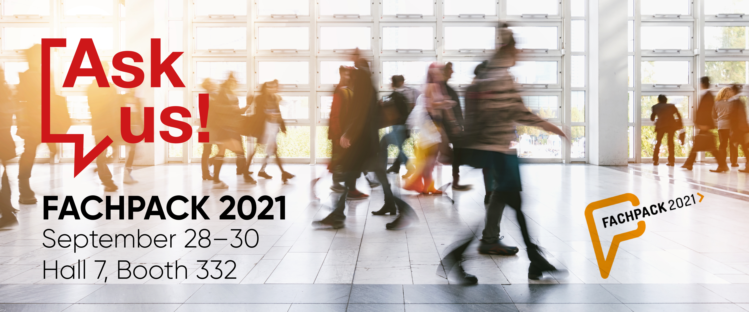

Caption: Offering a unique event experience, FachPack is an important agenda setter for the European packaging industry and its customers.

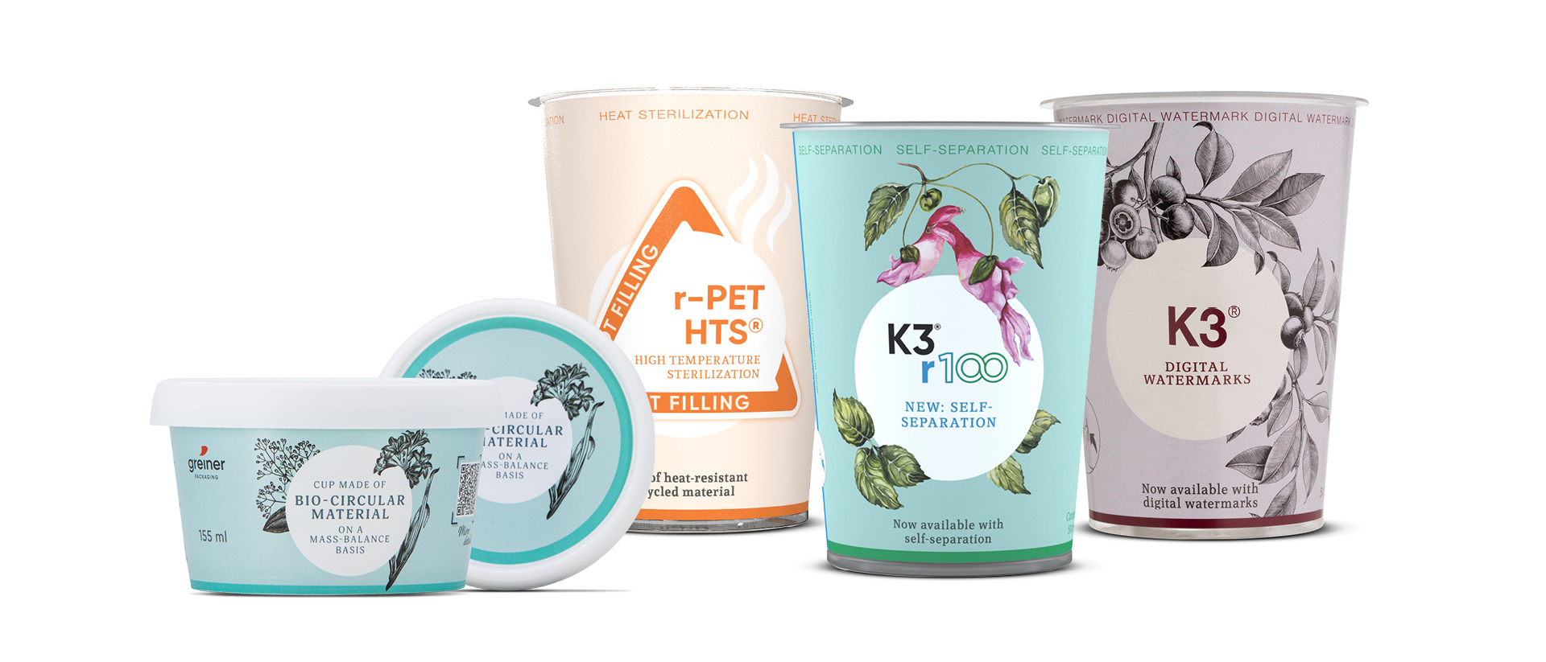
Caption: From recycled to alternative materials, from innovations like Digital Watermarks to the new K3® solution. It will all be on display at FACHPACK 2021 in Nuremberg.

About Greiner Packaging

Greiner Packaging is a leading European manufacturer of plastic packaging in the food and nonfood sectors. The company has enjoyed a reputation for outstanding solutions expertise in the fields of development, design, production, and decoration for more than 60 years. Greiner Packaging responds to the challenges of the market with two business units: Packaging and Assistec. While the Packaging unit focuses on innovative packaging solutions, the Assistec unit is dedicated to producing custom-made technical parts. Greiner Packaging employs a workforce of nearly 4,900 at more than 30 locations in 19 countries around the world. In 2020, the company generated annual sales revenues of EUR 692 million (including joint ventures), which represents approximately 35 percent of Greiner’s total sales.

Media contact at Greiner Packaging:
Roland Kaiblinger I Account Executive
SPS MARKETING GmbH | B 2 Businessclass | Linz, Stuttgart
Jaxstrasse 2–4, 4020 Linz, Austria
Tel.: +43 (0) 732 60 50 38-29
E-Mail: r.kaiblinger@sps-marketing.com
www.sps-marketing.com

More information:
www.greiner-gpi.com

