WorldStar Award 2022 for school milk packaging made from 100% r-PET

New year, new accolade: The World Packaging Organisation has announced the winners of the WorldStar Awards 2022. Among them was a joint project between Austria’s school milk producers and three Upper Austrian companies (PET-MAN, Greiner Packaging, and Starlinger Viscotec), which involved producing sustainable cups from 100% r-PET to be filled with school milk for the state of Upper Austria.

Kremsmünster, Austria (January 2022). Sustainability and a closed loop for plastics are front and center as we move into the new year. Since last spring, used school milk cups made from PET have been collected separately so that they could be recycled in a dedicated closed loop. And shortly before Christmas, this loop was closed for the first time. Used school milk cups collected before the fall were shredded, washed, recycled, and new r-PET cups were made from the material. The first crates containing freshly recycled r-PET cups have already been delivered to the school milk producers.

Flagship project for a circular economy
The flagship project proves that a circular economy is possible in the plastics and packaging industries. And the solution has now received a WorldStar Award 2022 in light of this accomplishment. The awards have been running since 1970 and are highly coveted, with 440 submissions from 37 countries around the world vying for the World Packaging Organisation’s stamp of approval. After picking up a Trigos and a Green Packaging Star Award in 2021, the project partners are proud to have their work recognized a third time with the WorldStar Award 2022. “It really is great to see our efforts receive this level of acknowledgment. For us, sustainability is not just a catchphrase – it is a duty we take very seriously. Thanks to the project, as well as doing our part to advance sustainability in general, children can be taught to treat nature responsibly from a young age,” says Manfred Stanek, CEO of Greiner Packaging. Johannes Strobl, who represents the Upper Austrian school milk producers, is also delighted: “The feedback I have received from the school milk producers is that the schools are excited about the project. They appreciate the fact that the used r-PET cups really are made into new cups.”
Starlinger Viscotec is also convinced that r-PET is the ideal choice for food packaging: “Our vision is to have a process in place for collecting and recycling packaging made from white r-PET,” says Herbert Hofbauer. “After all, used cups are a valuable material.”

Making cups from cups
The concept behind the sustainable packaging sounds simple enough, yet it is a unique proposition. Austria’s school milk producers supply schools and kindergartens directly with dairy products in r-PET cups. The children consume the drinks during recess, then the used cups are gathered and returned for recycling to the school milk producers. Once collected, these cups are picked up from the farm, washed, and shredded. The resulting flakes are then cleaned and processed. As was the case for the first time before Christmas, the extruded plastic sheet is subsequently used at Greiner Packaging to thermoform new r-PET cups, which are then refilled by the farmers and delivered once again to schools and kindergartens. This closed loop releases over 30% less CO₂ than reusable glass bottles, which are significantly heavier. Recycling the cups also requires less energy than processing reusable glassware, for instance, and produces less waste. The reason the cups can be recycled so easily is that they are unprinted and made from 100% monomaterial.

r-PET: material of the future
The recycling loop for r-PET makes it a material with a promising future. And as things stand, recycled PET is the only postconsumer secondary plastic approved for food applications in the EU. The white r-PET packaging can be reprocessed into food packaging, making it the ideal recyclable packaging solution for dairy products.

For further information about the r-PET school milk cup, please visit www.rPET-cup.com.

Technology facts:

- Technology: Thermoforming
- Decoration: None – making it ideal for recycling
- Material: r-PET

Text and image:
Credits: Greiner Packaging

Text document and high-resolution images for download:
https://mam.greiner.at/pinaccess/showpin.do?pinCode=TQAh4EsTsnbA

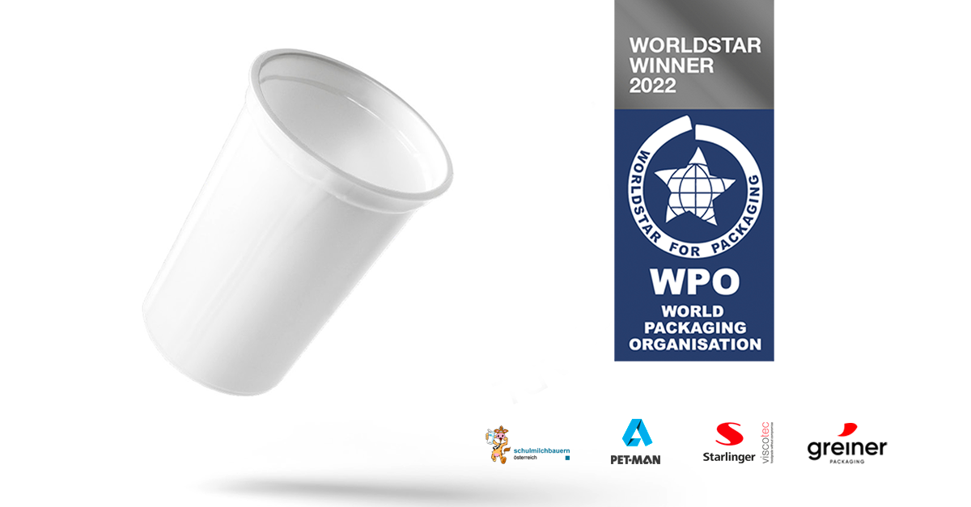

Caption: The Sustainably Packaged School Milk Project – a joint effort between Austria’s school milk producers and Upper Austrian companies PET-MAN, Starlinger Viscotec, and Greiner Packaging – won a WorldStar Award in 2022.

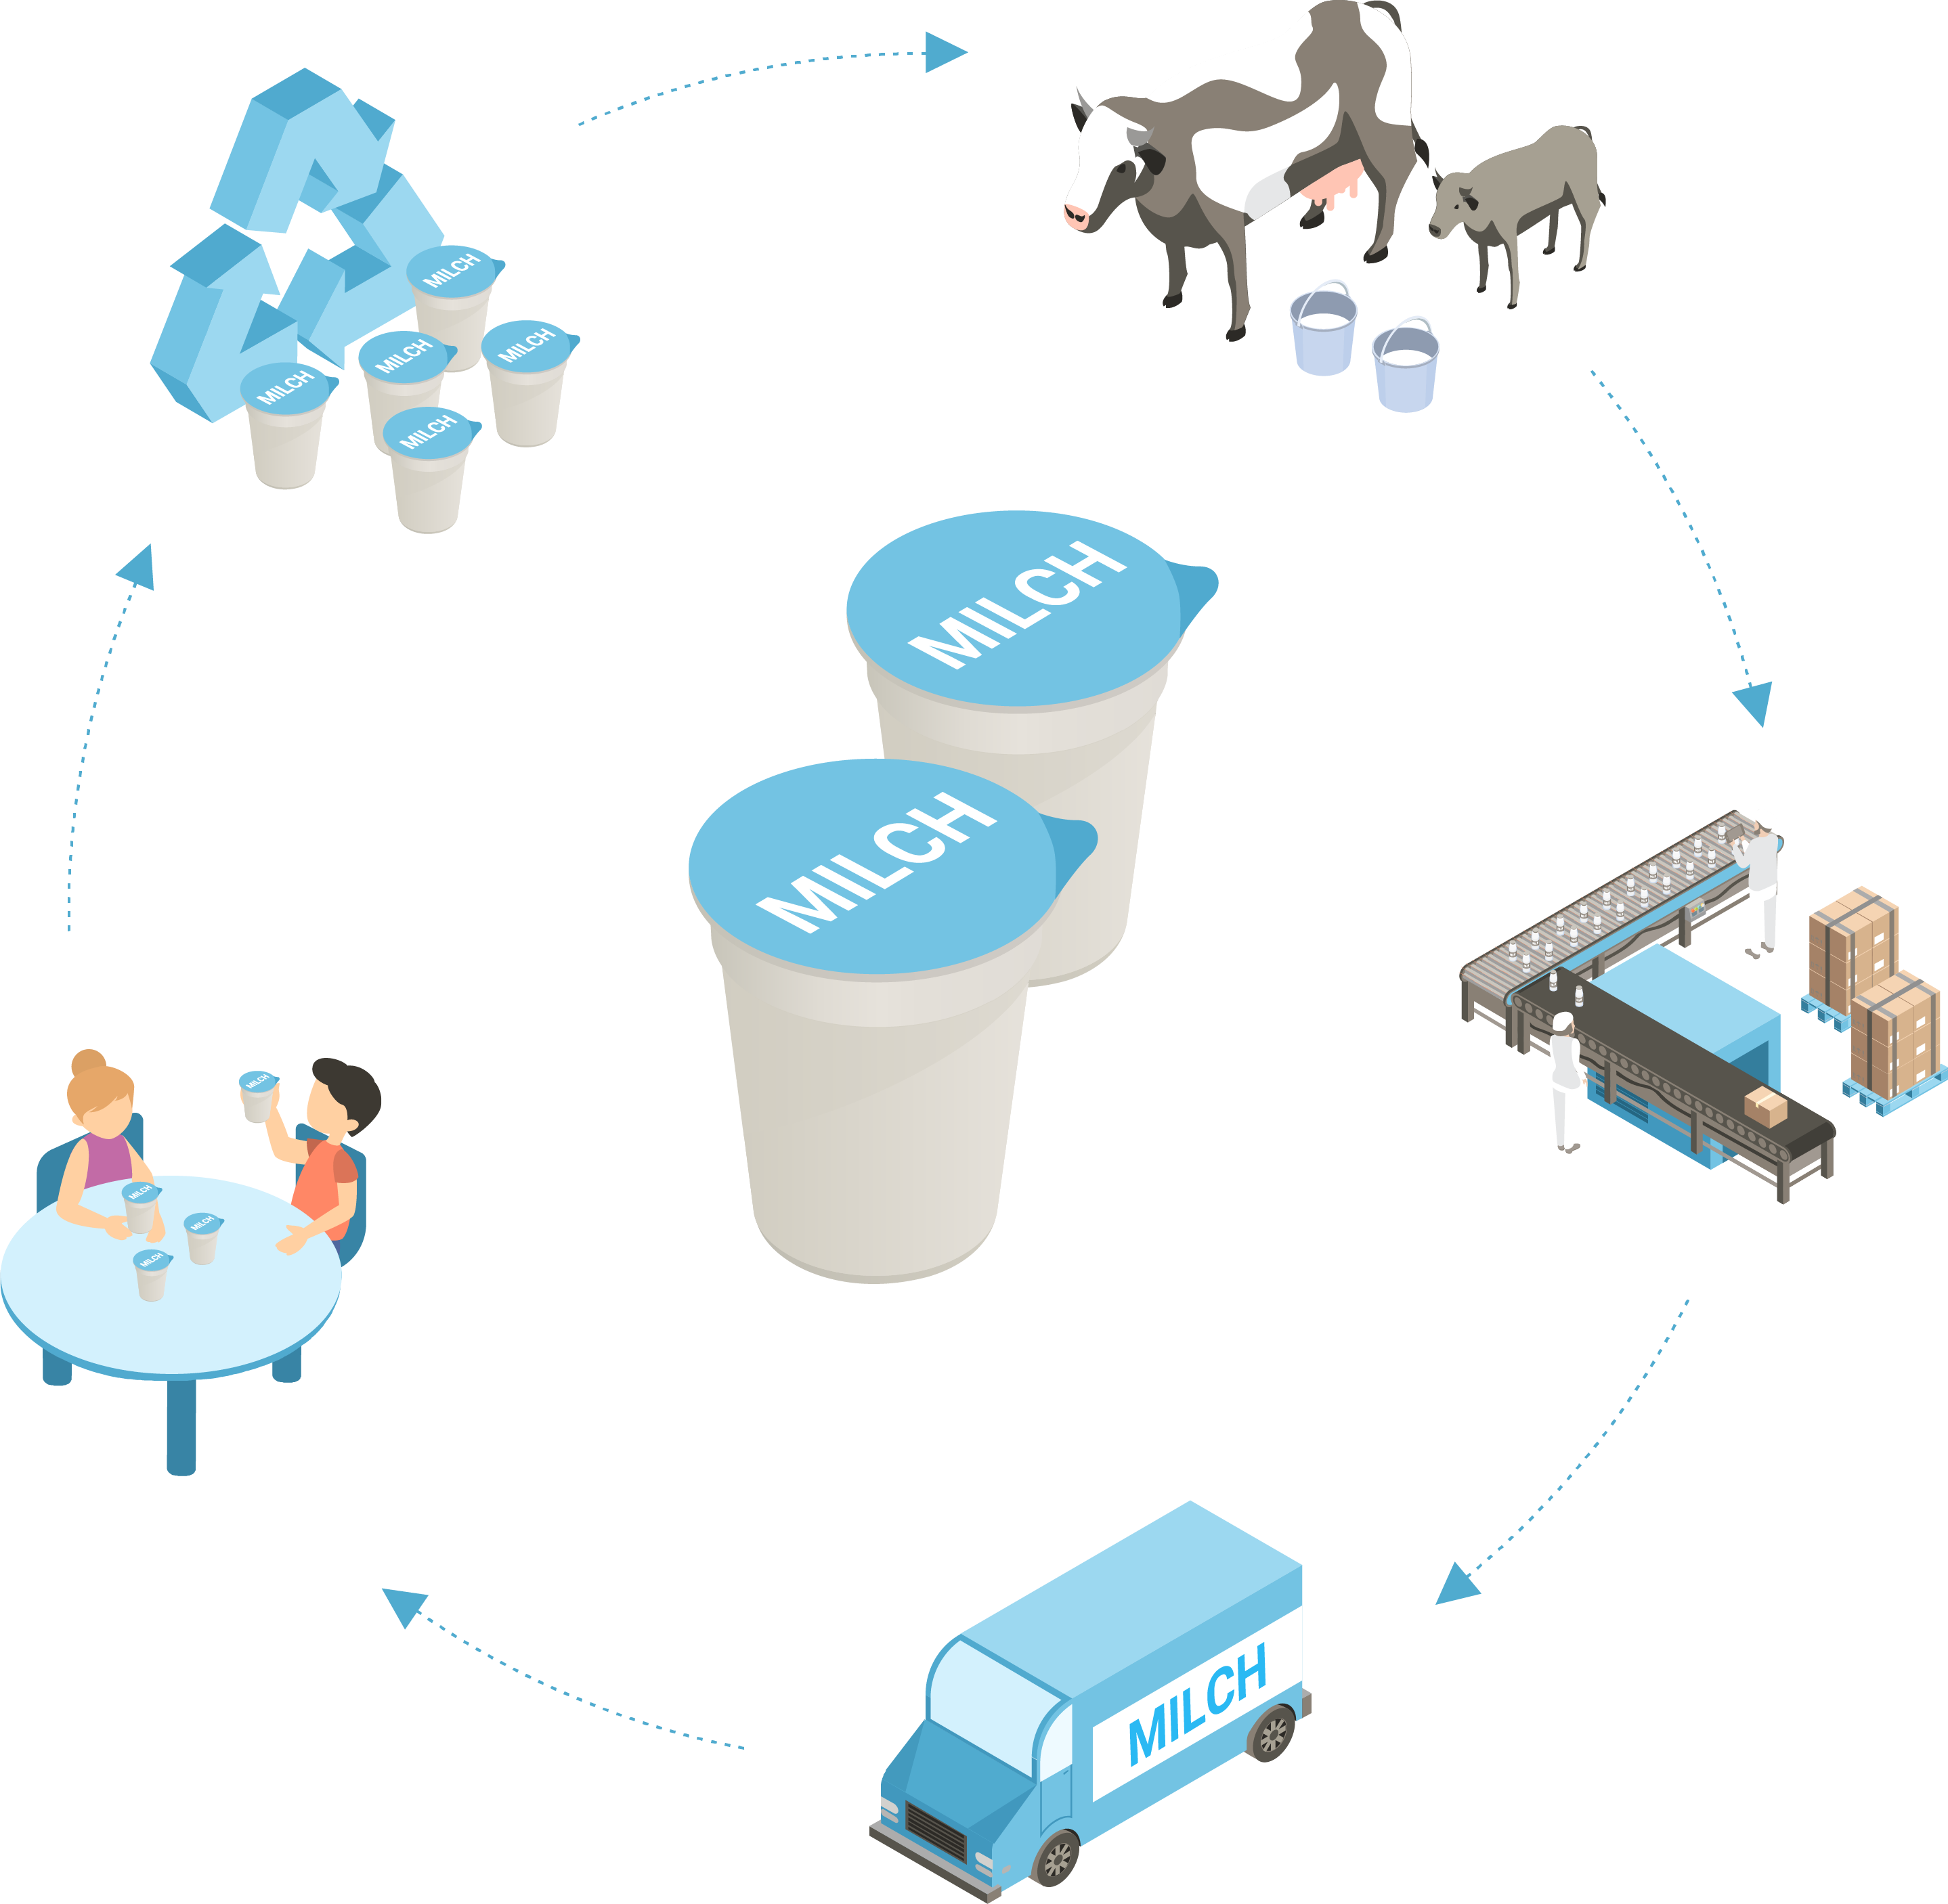

Caption: Children at Upper Austria’s kindergartens and schools can now enjoy their dairy products during recess in lightweight r-PET cups, which are kept in a closed loop.
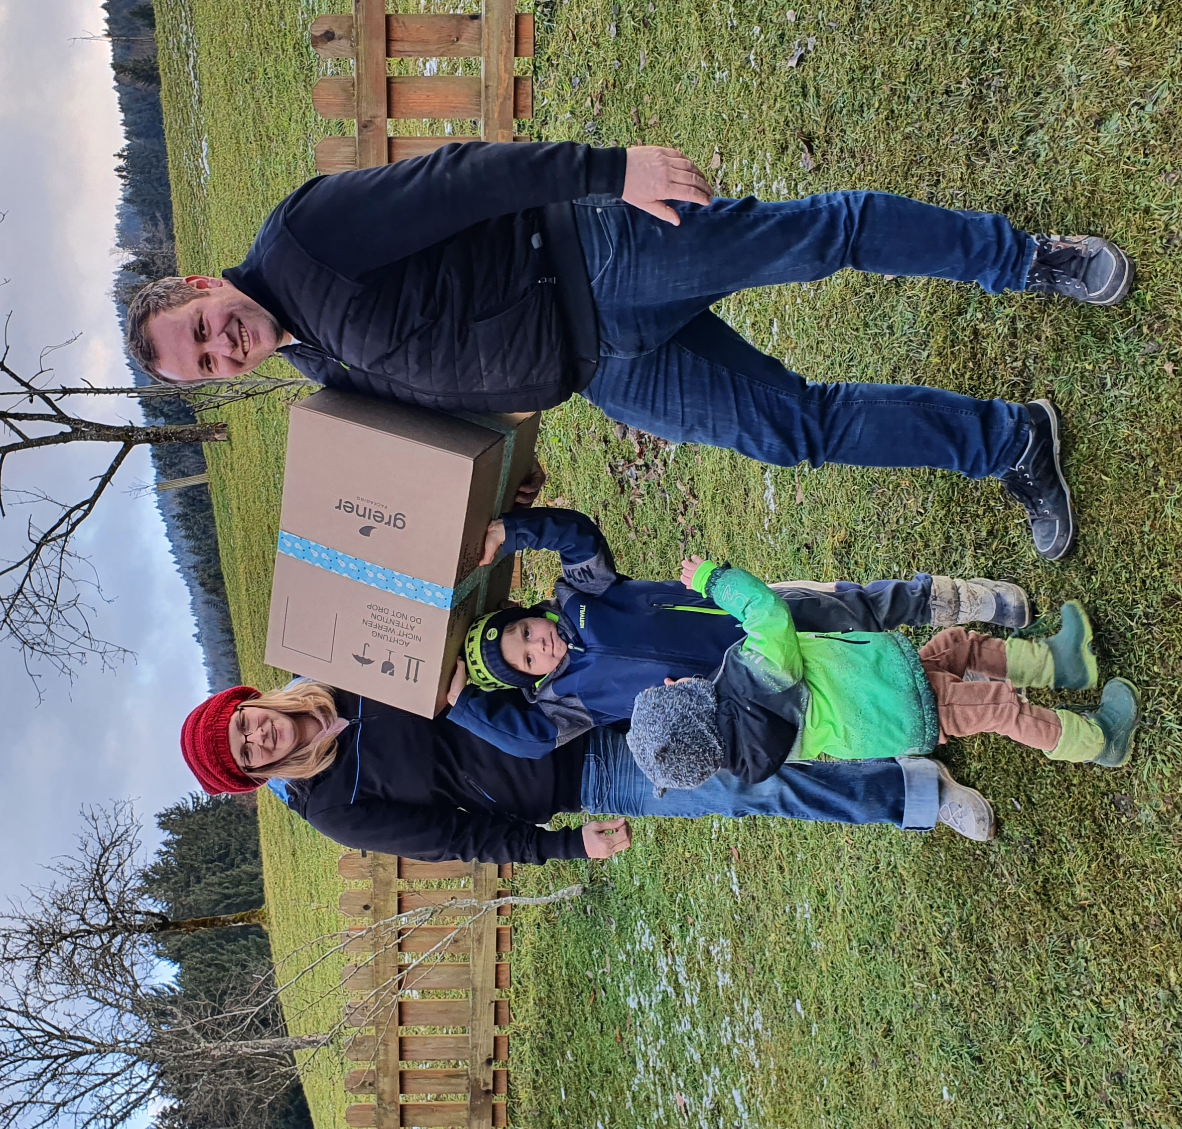

Caption: The Mayr-Miesenberger family is delighted to receive their first delivery of r-PET cups from the second loop, which will be filled with their school milk.

About the project partners

About the school milk
The school program run by Agrar Markt Austria (AMA) is part of the EU’s school fruit, vegetables, and milk scheme. Its aim is to help children and young people to eat a balanced diet. Almost all of the school milk suppliers are regional direct marketers. Fifty-four suppliers across Austria, 18 of which are located in Upper Austria, deliver the fresh products that have been ordered directly to the individual schools and kindergartens.

About PET-MAN GmbH
PET-MAN GmbH in Frankenburg, Upper Austria, supplies food-grade PET sheet made from recycled postconsumer material. With an annual production capacity of 12,000 metric tons of PET sheet, PET-MAN serves international customers in the packaging industry that produce solutions for food, medical, and technical applications. www.petman.at/en

About Starlinger Viscotec
Starlinger Viscotec is a division of Starlinger & Co. GmbH, the global market leader in the field of machinery and complete lines for woven plastic packaging production. For 16 years, Viscotec has been producing machines and systems for the refinement of recycled PET for food contact applications as well as extrusion lines for PET sheet made from up to 100% r-PET in Sankt Martin im Mühlkreis, Upper Austria, for export to customers around the world. The decontamination process for r-PET developed by Starlinger has been certified for food applications by various brand owners as well as national and international authorities. www.viscotec.at

About Greiner Packaging
Greiner Packaging is a leading European manufacturer of plastic packaging in the food and nonfood sectors. The company has enjoyed a reputation for outstanding solutions expertise in the fields of development, design, production, and decoration for more than 60 years. Greiner Packaging responds to the challenges of the market with two business units: Packaging and Assistec. While the Packaging unit focuses on innovative packaging solutions, the Assistec unit is dedicated to producing custom-made technical parts. Greiner Packaging employs a workforce of around 4,900 at more than 30 locations in 19 countries around the world. In 2020, the company generated annual sales revenues of EUR 692 million (including joint ventures), which represents approximately 35% of Greiner’s total sales. www.greiner-gpi.com

