100% r-PET: Harvest Moon and Greiner Packaging create sustainable cup packaging

German company Harvest Moon is dedicated to producing plant-based yogurt and milk alternatives that are good for both consumers and society. Its products, which are all certified organic, are made from ingredients that stand out by delivering both delicious flavor and a positive social impact – fair pay, decent working conditions, and great taste go hand in hand at Harvest Moon. Now the business is also taking a major step forward in terms of sustainable packaging, opting for cardboard-plastic combinations in which the cups are made of 100% r‑PET. These are produced by Greiner Packaging.

Kremsmünster, Austria (March 2022). Greiner Packaging’s stated aim is to keep plastic circulating in the economy for as long as possible. To this end, the packaging specialists look to work together with their customers to create new packaging solutions that can be recycled themselves and, ideally, contain recycled material, too. This was also the declared goal of Harvest Moon, and the plastic cups in the new cardboard-plastic solutions for its fermented yogurt alternatives are produced from 100% r-PET, making them super sustainable. No virgin material is used at all, and the new cups significantly cut down on carbon emissions. “By switching from virgin PP to r‑PET, we can reduce CO₂ emissions by around 40%*,” explains Jan Srnka, sales manager at Greiner Packaging.

Sustainable material
A sustainable plastic, r-PET (recycled polyethylene terephthalate) is lightweight, shatterproof, and free of plasticizers. Because the new cups are made from 100% recycled, unprinted r-PET monomaterial, they can be processed into 100% food-safe cups again and again as long as the appropriate collection streams are used. Recycling the cups requires less energy than using virgin material and produces less waste.

Sustainable packaging
But aside from the material used, cardboard-plastic combinations have a number of other sustainable properties. The cardboard wrap, which can be made from recycled material, lends sturdiness to the plastic cup so that it can be produced with particularly thin walls. This wrap is especially easy for consumers to detach from the cup thanks to a new, innovative tear-off system, with the two components then disposed of separately and recycled. Since the white or transparent plastic cup is unprinted, it can be recycled very effectively. In addition, the carbon footprint of K3® cups is significantly smaller than that of alternative packaging solutions.

Joint mission
“We want the work we do to benefit society. We have a real taste for doing good – and for us, that includes using sustainable packaging for our yogurt alternatives. In Greiner Packaging, we have found a partner that can fully meet our expectations in this regard and shares our belief in eco-friendly cooperation,” says Lena Lembcke, marketing and brand manager at Harvest Moon.

Harvest Moon’s products are available from organic specialty stores and food retailers across Europe. And its new 100% r-PET cups from Greiner Packaging have been on the shelves since January 2022.

* Estimate based on the carbon footprint for the packaging material’s annual consumption figures. This includes production and the end-of-life phase but does not include the usage phase or transportation. The estimate may vary in response to changes in the underlying assumptions.

Packaging details:
- Technology: Thermoforming
- Decoration: K3® cardboard-plastic combination
- Material: r-PET
Text and image:

Text document and high-resolution images for download:
https://mam.greiner.at/pinaccess/showpin.do?pinCode=5zSOSAcx5GCE

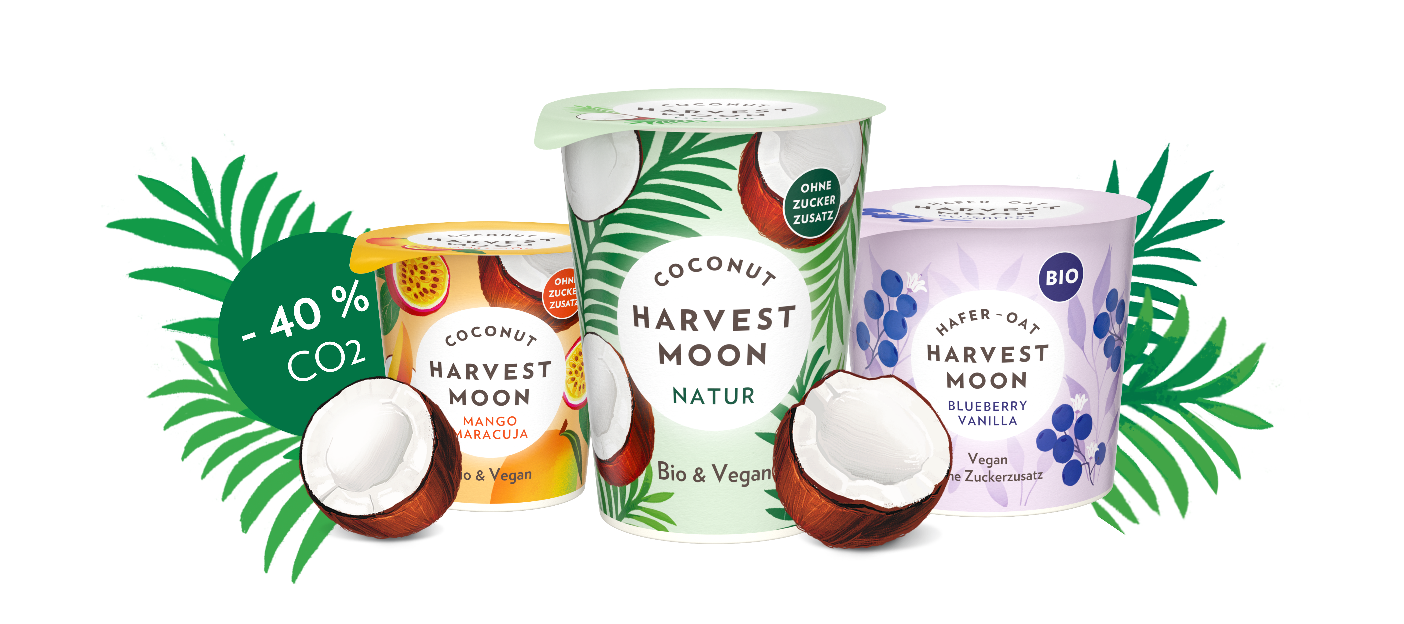

Caption: Harvest Moon has now switched the plastic cups for its plant-based yogurt alternatives to 100% recycled PET.

Credit: © Harvest Moon

About Greiner Packaging

Greiner Packaging is a leading European manufacturer of plastic packaging in the food and nonfood sectors. The company has enjoyed a reputation for outstanding solutions expertise in the fields of development, design, production, and decoration for over 60 years. Greiner Packaging responds to the challenges of the market with two business units: Packaging and Assistec. While the Packaging unit focuses on innovative packaging solutions, the Assistec unit is dedicated to producing custom-made technical parts. Greiner Packaging employs a workforce of almost 4,900 at more than 30 locations in 19 countries around the world. In 2020, the company generated annual sales revenues of EUR 692 million (including joint ventures), which represents around 35% of Greiner’s total sales.

Media contact for Greiner Packaging:
Roland Kaiblinger I Account Executive
SPS MARKETING GmbH | B 2 Businessclass | Linz, Stuttgart
Jaxstrasse 2–4, 4020 Linz, Austria
Phone: +43 (0) 732 60 50 38-29
Email: r.kaiblinger@sps-marketing.com

For further information, visit:
greiner-gpi.com

About Harvest Moon

Established in 2011, Harvest Moon is a pioneer in creating plant-based organic dairy products. Its range of products includes yogurt alternatives made from oats, coconut, and cashew as well as three plant-based organic milk alternatives that taste and foam like cow’s milk.
The company and its staff are guided by a passion for healthy, natural food, along with a conviction that their products can do good for both the consumer and society – thanks to good flavor, decent working conditions, and fair purchasing prices. The Hamburg-based business donates 1% of its sales to local charitable projects in Germany to help create a fairer and more sustainable world that will also benefit future generations.

Media contact at Harvest Moon:
Lena Lembcke
Phone: +49 (0) 40 334 607 404
Email: lena@harvestmoon.de

For further information:
harvestmoon.de/en/press

