“Join the circular revolution” with Greiner Packaging at FACHPACK 2022

As a leading packaging producer, Greiner Packaging is committed to delivering innovation for a circular world – one where the same resources can be used again and again. The company’s approach is rooted in the guiding principle: reduce, reuse, recycle. This ability to innovate sustainably will also be at the heart of the packaging experts’ appearance at FACHPACK. From September 27 to 29, they will be at the show in Nuremberg, Germany, to present their future-ready solutions, designed to minimize resource use.

Kremsmünster, Austria (September 2022). “Join the circular revolution!” is Greiner Packaging’s rallying cry ahead of this year’s FACHPACK. At the international packaging, technology, and processing trade show, the sustainable family business will be showcasing its most innovative solutions and latest concepts for realizing a responsible circular economy. The packaging producer has been putting its innovation skills to work for decades to promote the intelligent use of valuable resources. Taking “reduce, reuse, recycle” as its guiding principle, Greiner Packaging is rising to the challenges of the future by providing innovative solutions on multiple fronts, maximizing everything from reductions in the use of valuable materials to reuse, recyclability, and the use of recycled materials.

Reduce: using less material, caring for our planet more
The first theme Greiner Packaging plans to focus on at the trade show poses something of a dilemma for the packaging industry, because the most environmentally friendly material is one that is not used at all. That is why reducing the amount of material used is an important strategy for maximizing the sustainability of the packaging that is nevertheless required. This, in turn, cuts down on both weight and CO₂ emissions. With this in mind, Greiner Packaging will be bringing one of its largest lightweight solutions to FACHPACK: the reduced-weight 1-liter IML bucket. As well as being suitable for large quantities of various foods and dishes, the large plastic bucket – which features a lid and handle – also impresses due to its light weight. Compared with previous models, the bucket’s weight has in fact been reduced from 45 grams to 34 grams (i.e., by around ⅖ oz), cutting the amount of plastic by as much as 25%. Another product to be exhibited is the IML Lightweight Cup, a yogurt cup that can be decorated attractively. This, too, boasts a significant 20% reduction in material usage, which by extension means a substantially smaller carbon footprint.

Reuse: the best choice, time and time again
As another area in which Greiner Packaging is advancing the development of sustainable packaging solutions, reuse will be the second major theme of the company’s trade show appearance. Innovative reuse concepts are on trend for a reason – the more often a resource can be reused, the better. Packaging manufacturers are in need of innovations that help to extend the service life of materials while also being user-friendly for consumers and extremely appealing due to their design. The display stands at Greiner Packaging’s booth will showcase two model examples from this area: the Reuse Drinking Cup and the Reuse Bowl. Both are smart and sustainable alternatives to single-use cups and bowls. These sturdy, dishwasher-safe, and shatterproof containers made of high-quality polypropylene were specially created for reuse systems, and they are equally suitable for hot and cold beverages or dishes at any temperature. As a result, solutions like these have a role to play in reducing waste.

Recycle: turning packaging back into packaging
The third theme Greiner Packaging will be highlighting at FACHPACK 2022 as part of its sustainability offensive is the ongoing development of recyclable packaging with the aim of keeping plastic circulating in the economy for as long as possible. Another goal is to use as much recycled material as possible. For this reason, Greiner Packaging designs its solutions for ease of recycling while taking care to maximize recycled content in production. An excellent example of this is a cup made by Greiner Packaging for Harvest Moon. The inside of the cardboard-plastic combination is made of 100% r-PET instead of virgin PP. This means that the cup is not only almost completely recyclable, but also produced almost exclusively from materials that have already been recycled. Another product innovation that will be on show from the cardboard-plastic combinations range will be K3® r100. In developing this flagship solution, Greiner Packaging has made it possible for the cardboard wrap to separate itself from the plastic cup prior to sorting during the waste collection process – before the packaging even arrives at the recycling facility. This innovative development makes cardboard-plastic combinations substantially easier to recycle, with the cardboard and plastic assigned to the correct material streams during the initial sorting process before being recycled.

Working together toward a more sustainable future
Greiner Packaging will be exhibiting these and a host of other innovative and future-facing solutions at FACHPACK. The packaging specialists are particularly looking forward to speaking with visitors and other industry experts. After all, we have to work together if we want to make a global circular economy a reality.

Greiner Packaging at FACHPACK 2022:
Hall 7 (7-436)

Text and image:

Text document and high-resolution images for download:
https://mam.greiner.at/pinaccess/showpin.do?pinCode=8KJ8CKvHVoOq

Photo Credit: Greiner Packaging

(Pictures on the next page)

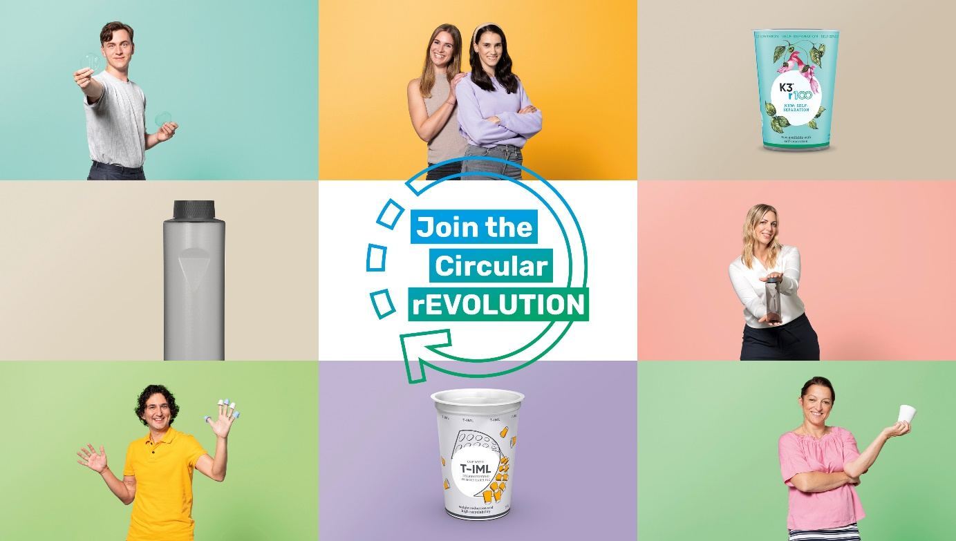
Caption: “Join the circular revolution” is Greiner Packaging’s motto. The new campaign aims to shine a spotlight on sustainable packaging solutions that embody the “reduce, reuse, recycle” maxim.
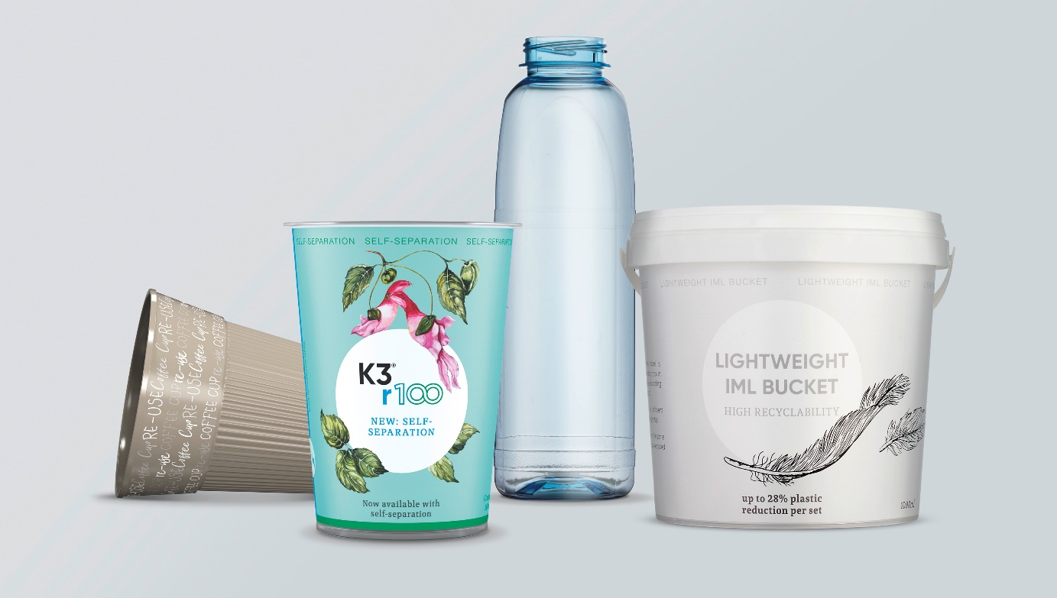
Caption: At FACHPACK, Greiner Packaging will be showcasing a host of products that reflect the “reduce, reuse, recycle” approach, including the Reuse Drinking Cup, K3® r100, and reusable and lightweight packaging solutions.

About Greiner Packaging
Greiner Packaging is a leading European manufacturer of plastic packaging in the food and nonfood sectors. The company has enjoyed a reputation for outstanding solutions expertise in the fields of development, design, production, and decoration for over 60 years. Greiner Packaging responds to the challenges of the market with two business units: Packaging and Assistec. While the Packaging unit focuses on innovative packaging solutions, the Assistec unit is dedicated to producing custom-made technical parts. Greiner Packaging employs a workforce of over 4,900 people at more than 30 locations in 19 countries around the world. In 2021, the company generated annual sales revenues of EUR 772 million (including joint ventures), which represents almost 35% of Greiner’s total sales.

Media contact for Greiner Packaging:
Charlotte Enzelsberger
Global Expert Communication

Greiner Packaging International GmbH
Gewerbestrasse 15, 4642 Sattledt, Austria
Cell: +43 664 88218364
Email: C.Enzelsberger@greiner-gpi.com
Website: www.greiner-gpi.com

Further information:
www.greiner-gpi.com

