331.5 tons of plastic waste collected already: Greiner Packaging extends cooperation with Plastic Bank

- Greiner Packaging and Plastic Bank have been partners since 2019

- A truly circular economy is using plastic in packaging, full circle from collection to use. Greiner Packaging is helping to advance the circular economy by collecting plastic to be put back into the global supply chain and improving the lives of collection community members in the Philippines

- In recent years, 331.5 tons of plastic waste were collected, which corresponds to 16.5 million plastic bottles

Kremsmünster, Austria, November 2022. In recent years, 331.5 tons of plastic waste were collected, the equivalent of 16.5 million plastic bottles. Together in the fight against plastic waste entering the world’s oceans, Greiner Packaging has been cooperating with Plastic Bank since 2019. Greiner Packaging supported the launch of five Plastic Bank collection branches in Manila in the Philippines – one of the world’s largest plastic waste-producing countries.

Advancing a circular economy and fighting poverty

Plastic Bank empowers Ocean Stewards to stop ocean plastic. The ethical collection communities exchange plastic for life-improving benefits. Exchanges are recorded through a blockchain-secured platform that enables traceable collection, secures income, and verifies reporting. The collected material is processed into Social Plastic® feedstock for reuse in products and packaging.

We still have a long way to go before we achieve a global circular economy. Partnerships such as the ones between Greiner Packaging and Plastic Bank are an essential step in the right direction. In addition to advancing a circular economy and preventing plastic waste in the oceans, it also improves the lives of those who help collect it.

Establishing plastic waste as a valuable raw material

"Our partnership demonstrates that a circular economy is possible. The cycle from plastic waste carelessly thrown into the environment to recycled granulate that companies can use to make new products is a prime example of the potential offered by initiatives like this," says Manfred Stanek, CEO of Greiner Packaging.

Plastic Bank is revealing value in plastic. Collection community members no longer see plastic as waste but as a valuable resource. This is a significant step towards reducing plastic pollution in the oceans. By giving collection community members access to life-improving benefits such as secure income, health, work, and life insurance, digital connectivity, and social and fintech services. Plastic Bank empowers communities to build a better future – not only in the Philippines but also in, Indonesia, Brazil, and Egypt.

Continuation of the successful cooperation

To continue the fight against plastic waste in the world's oceans, Greiner Packaging is extending its successful cooperation with Plastic Bank for another year. In recent years, Plastic Bank has been able to collect 331.5 tons of plastic waste – the equivalent of 16.5 million plastic bottles – with the support of Greiner Packaging. Pollution of the oceans is one of the major ecological challenges. As a packaging company, Greiner Packaging is aware of its responsibility towards nature and society.

More information about the cooperation can be found on our website: Our cooperation with Plastic Bank (greiner-gpi.com)
Our video on the opening of our first joint plastic collection branch in Manila can be found here:
Plastic. Too Precious to Waste. Greiner Packaging is an official partner of Plastic Bank. - YouTube

Text and image:

Text document and high-resolution images for download:
https://greinerpackaging.canto.de/b/HHE0L

Images for royalty-free use, credit: Plastic Bank

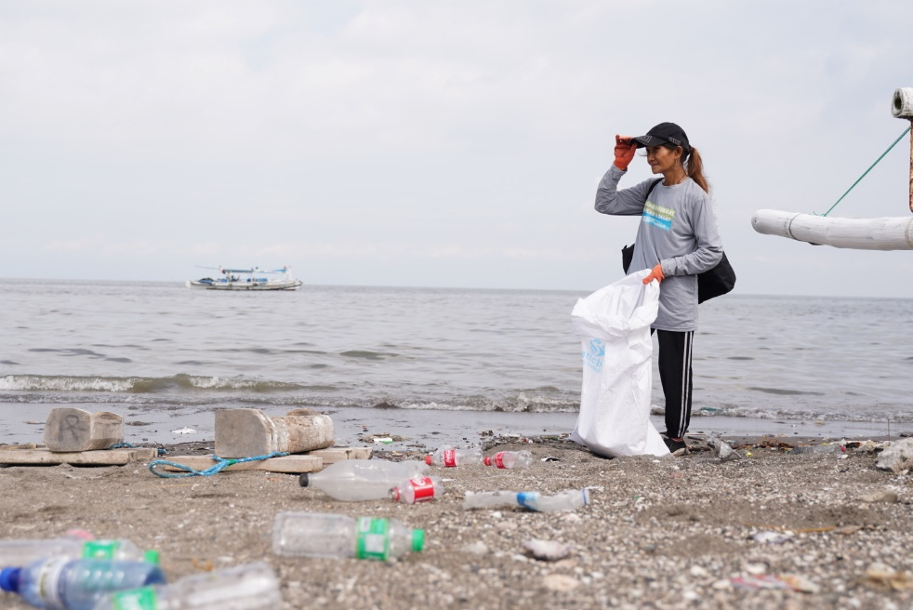

Caption: The partnership between Greiner Packaging and Plastic Bank has been in place since 2019, since when 331.5 tons of plastic waste have been collected and subsequently recycled.

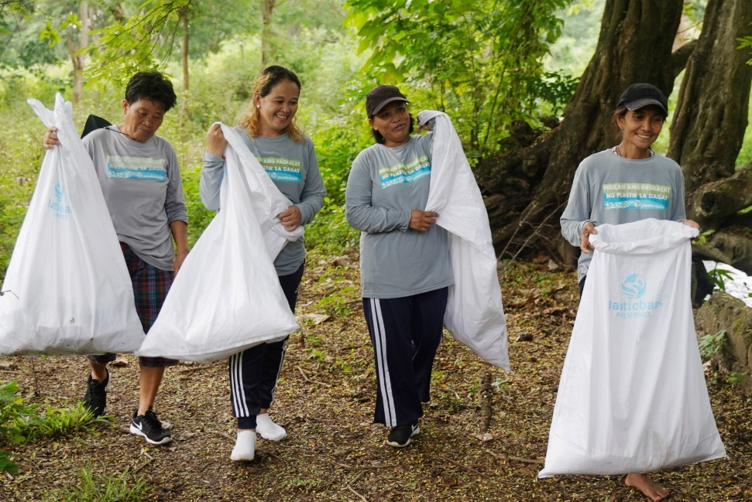
Caption: The Plastic Bank collectors take the plastic waste to collection stations. There it is pre-sorted before being taken to a recycling company. A win-win-win situation for the environment, the collectors and the global circular economy.

About Plastic Bank
Plastic Bank empowers Ocean Stewards to stop ocean plastic. Our ethical collection communities exchange plastic for life-improving benefits. Exchanges are recorded through a blockchain-secured platform that enables traceable collection, secures income, and verifies reporting. The collected material is processed into Social Plastic® feedstock for reuse in products and packaging.

Plastic Bank, Social Plastic®, and Alchemy™ are trademarks of The Plastic Bank Recycling Corporation.

Learn more at www.plasticbank.com

About Greiner Packaging
Greiner Packaging is a leading European manufacturer of plastic packaging in the food and nonfood sectors. The company has enjoyed a reputation for outstanding solutions and expertise in the fields of development, design, production, and decoration for over 60 years. Greiner Packaging responds to the challenges of the market with two business units: Packaging and Assistec. While the Packaging unit focuses on innovative packaging solutions, the Assistec unit is dedicated to producing custom-made technical parts. Greiner Packaging employs a workforce of over 4,900 people at more than 30 locations in 19 countries around the world. In 2021, the company generated annual sales revenues of EUR 772 million (including joint ventures), which represents almost 35% of Greiner’s total sales.

Learn more at www.greiner-gpi.com

Media Contact of Greiner Packaging
Alexandria Mitterbaur
Global Head of Marketing

Greiner Packaging International GmbH
Gewerbestraße 15, 4642 Sattledt, Austria
Mobile: +43 664 88218434
E-mail: A.Mitterbaur@greiner-gpi.com

