Greiner Packaging: Cardboard-plastic combination K3® turned 40!

In late 1982, the packaging market was revolutionized by a true innovation: the cardboard-plastic combination. K3® has remained consistently popular ever since, and countless products are sold in this sustainable packaging today – from yogurts and spreads through ready meals and salads to laundry detergents and dishwasher tablets. Greiner Packaging is now celebrating the 40th anniversary of its groundbreaking packaging solution.

- The cardboard-plastic combination was developed in 1982
- Since then, numerous innovations have shaped K3®’s trajectory – most recently, self-separating K3® r100
- Greiner Packaging launches campaign to celebrate its success story’s anniversary

Kremsmünster, Austria (January 2023). In 1982, a packaging innovation was born out of the oil crisis underway at the time. The cardboard-plastic combination was developed in the small Swiss town of Diepoldsau with a simple aim: to save plastic.

Peter Akermann, known at Greiner Packaging as “the father of K3®,” is proud of the results: “The dramatic increases in the price of oil triggered by the oil crisis of the 1970s created a very challenging situation for many sectors, including the plastics industry. With that in mind, we made it our mission to develop a packaging design that would use less plastic while protecting the product inside just as effectively. A team of Swiss colleagues worked tirelessly on the development project over many months and carried out an extensive battery of product tests. Finally, we arrived at the solution, which subsequently achieved market success under the name K3®.”

Reducing material usage has always been one of the cardboard-plastic combination’s greatest benefits – initially for financial reasons and now especially with regard to sustainability.

K3® boasts an impressive array of advantages, even after 40 years
K3® packaging consists of two components: a plastic cup and a cardboard wrap. The cardboard wrap lends sturdiness to the plastic cup so that the cup can have particularly thin walls. Using less plastic to produce a K3® cup also significantly reduces the associated CO₂ emissions.
In addition, cardboard-plastic combinations are readily recyclable – it is no hassle for consumers to detach the cardboard wrap from the plastic cup to dispose of them separately. The new, patent-protected Greiner Packaging tear-off system makes the separation process extra simple. The unprinted cup produces top-quality recycled material.
K3® can also be made with material recovered from recycling, with the option to produce both the cardboard wrap and the plastic cup from as much as 100% recycled material – up to 100% r-PET in the case of the cup.

“There are plenty of reasons why cardboard-plastic combinations have been on a successful journey for decades. At Greiner Packaging, we are especially proud both to have invented this product category and to have kept on developing it. I have been working on K3® products for 20 years now and have helped to bring nine K3® innovations to market during that period alone. We take particular pride in our latest innovation, K3® r100, whose cardboard wrap automatically separates from the plastic cup during the waste disposal process,” says Jens Krause, sales director at Greiner Packaging.

Greiner Packaging celebrates with anniversary campaign
To commemorate 40 years of cardboard-plastic combinations, Greiner Packaging has launched a dedicated anniversary campaign, celebrating its invention of K3®. Following in the footsteps of Elvis, whom countless impersonators have tried to copy over the years, K3® is also a pioneering presence that is often imitated and yet remains the only true original.

More information about our K3® anniversary campaign can be found on our anniversary landing page!

Text and image: Greiner Packaging

Text document and high-resolution images for download:
https://greinerpackaging.canto.de/b/JA9R2

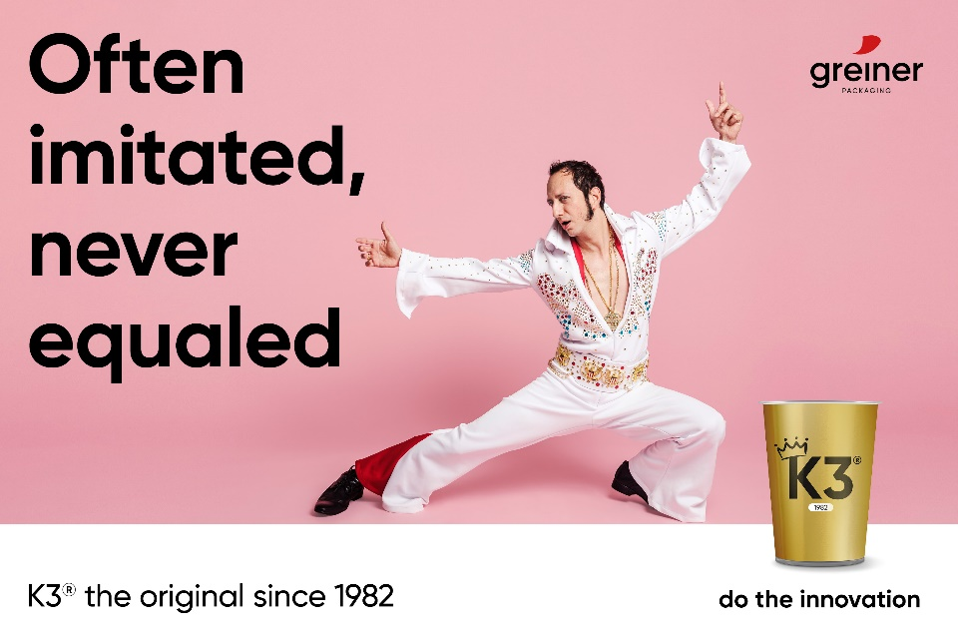

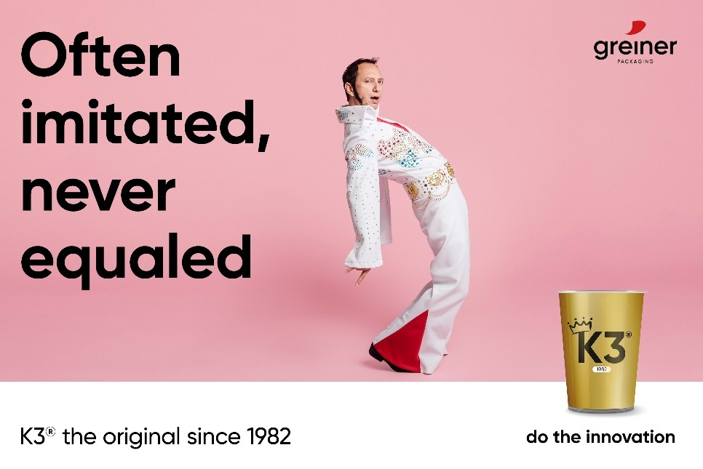

Caption: Greiner Packaging is celebrating 40 years of its K3® cardboard-plastic combination. Just like Elvis, K3® is also a pioneering presence that is often imitated and yet remains the only true original.

About Greiner Packaging
Greiner Packaging is a leading European manufacturer of plastic packaging in the food and nonfood sectors. The company has enjoyed a reputation for outstanding solutions and expertise in the fields of development, design, production, and decoration for over 60 years. Greiner Packaging responds to the challenges of the market with two business units: Packaging and Assistec. While the Packaging unit focuses on innovative packaging solutions, the Assistec unit is dedicated to producing custom-made technical parts. Greiner Packaging employs a workforce of over 4,900 people at more than 30 locations in 19 countries around the world. In 2021, the company generated annual sales revenues of EUR 772 million (including joint ventures), which represents almost 35% of Greiner’s total sales.
Learn more at www.greiner-gpi.com

Media Contact of Greiner Packaging
Alexandria Mitterbaur
Global Head of Marketing

Greiner Packaging International GmbH
Gewerbestraße 15, 4642 Sattledt, Austria
Mobile: +43 664 88218434
E-mail: A.Mitterbaur@greiner-gpi.com

