Interpack 2023: Greiner Packaging makes renewed call for sustainable packaging

“Join the circular revolution” is the call that Greiner Packaging has been putting out to its customers and its entire network to encourage them to work together to build a sustainable future. At Interpack 2023, the company will be adding further emphasis with the prompt to “do it!” Visitors to the trade show will be able to discover a number of impressive circular packaging solutions from Greiner Packaging at booth C42 in hall 10.

- At Interpack 2023, Greiner Packaging will be calling for joint action with its rallying cry, “Join the circular revolution. Do it!”
- Visitors to booth C42 in hall 10 will be able to learn all about packaging that fulfills the “reduce, reuse, recycle” criteria
- Trade show highlights will include the self-separating K3® r100 cardboard-plastic cup, solutions made from recycled PET, and a variety of reuse concepts

The amendment to the EU Packaging and Packaging Waste Regulation, the EU Single-use Plastics Directive, and various other agreements all make one thing clear: The world of packaging as we know it is a thing of the past. A different, sustainable future lies ahead. But getting there will require genuine innovations and a willingness to embrace change. Greiner Packaging will be presenting its own ideas at Interpack 2023.

Reduce: sometimes, less is more
Above all, a sustainable future is one in which we reduce both resource consumption and CO₂ emissions. Cardboard-plastic combinations from Greiner Packaging deliver on both fronts by minimizing their use of plastic. Visitors to Interpack 2023 will have the chance to discover the extensive array of possibilities offered by K3® packaging for themselves. There are other solutions that keep plastic content to a minimum, too, such as thermoformed IML cups and ultra-lightweight 1-liter IML buckets, which Greiner Packaging will also be showcasing at booth C42 in hall 10.

Reuse: returnables that can be used again and again
Reuse solutions are packaging items that circulate as part of a rinse and return system, allowing them to be used multiple times. At its booth, Greiner Packaging will be exhibiting a huge variety of solutions in this category, including reusable coffee cups, bowl-type containers, and milk bottles.

Turning packaging back into packaging
Recycling is an important component of a well-functioning circular economy. At Interpack 2023, Greiner Packaging will shine a light on the requirements that packaging must meet to be considered readily recyclable. In a special highlight on the subject of recyclability, visitors will have the chance to familiarize themselves with the latest innovation from Greiner Packaging’s cardboard-plastic combinations range. K3® r100 has been designed so that its cardboard wrap separates itself from its plastic cup during the waste collection process, achieving up to 98% recyclability. Customers like Austrian dairy giant Berglandmilch have been quick to take advantage of the exciting new design.

A wealth of packaging solutions containing recycled material will also be on show at Greiner Packaging’s booth, including examples of the cardboard-plastic combinations made from 100% r-PET that Greiner Packaging produces for Harvest Moon. In addition, visitors to Interpack will be able to take a close look at highly thermostable PET cups that can incorporate recycled content and withstand temperatures of up to 120°C (248°F). This property makes them particularly advantageous for dairy products that have to be hot-filled.

“Do it!”
With its call to “do it!” Greiner Packaging is reaffirming its commitment to making sustainable packaging a reality. “We see it as our mission to play an active role in shaping tomorrow’s packaging world. It is clear that this journey is no walk in the park and we must work together to reach our destination. That is why having a lively exchange of ideas with our customers and partners is particularly important to us. With that in mind, we are already looking forward to engaging in all kinds of interesting conversations at Interpack 2023,” says Jörg Sabo, global marketing and innovation director at Greiner Packaging.

Interpack 2023
May 4–10, 2023
Messe Düsseldorf
Booth C42, hall 10
More information: Landingpage

Text and image: Greiner Packaging

Text document and high-resolution images for download:
https://greinerpackaging.canto.de/b/RD5Q3

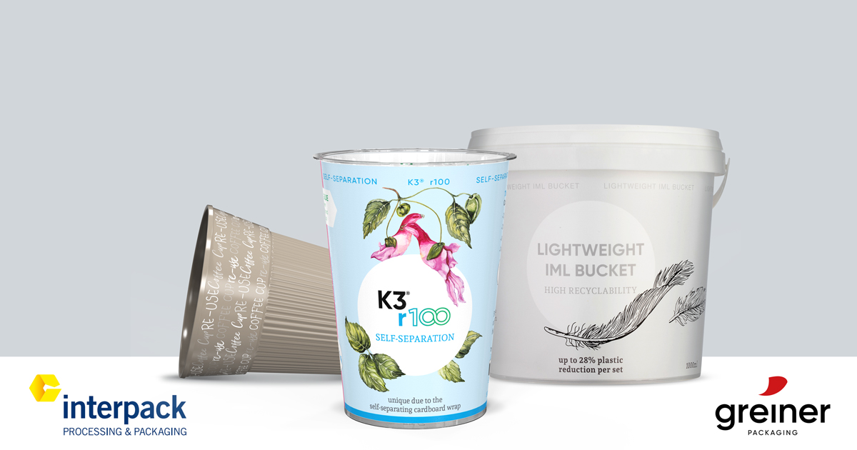

Caption: Visitors to the Greiner Packaging booth C42 / hall 10 at Interpack 2023 will be presented the company’s packaging solutions that fulfill the “reduce, reuse, recycle” criteria

About Greiner Packaging

Greiner Packaging is a leading European manufacturer of plastic packaging in the food and nonfood sectors. The company has enjoyed a reputation for outstanding solutions expertise in the fields of development, design, production, and decoration for over 60 years. Greiner Packaging responds to the challenges of the market with two business units: Packaging and Assistec. While the Packaging unit focuses on innovative packaging solutions, the Assistec unit is dedicated to producing custom-made technical parts. Greiner Packaging employs a workforce of more than 4,900 at more than 30 locations in 19 countries around the world. In 2021, the company generated annual sales revenues of EUR 772 million (including joint ventures), which represents almost 35% of Greiner’s total sales.

Media contact for Greiner Packaging:
Alexandria Mitterbaur
Global Head of Marketing

Greiner Packaging International GmbH
Gewerbestraße 15, 4642 Sattledt, Austria
Mobile: +43 664 88218434
E-mail: A.Mitterbaur@greiner-gpi.com

