K3® r100 wins Green Packaging Star Award

Berglandmilch is the first company in Austria to use the self-separating K3® r100 packaging. For its product innovation, Greiner Packaging has now received the Green Packaging Star Award, which is presented annually by the Austrian magazine KOMPACK.

- The Green Packaging Star Award honors sustainable solutions for packaging
- This year's winner in the category “environmentally friendly product” is the self-separating cardboard-plastic cup K3® r100, which Greiner Packaging is producing for the traditional company Berglandmilch
- Greiner Packaging has received the Green Packaging Star Award multiple times already in the past

Kremsmünster, October. The Green Packaging Star Awards have been running since 2008. The awards are intended to highlight eco-friendly packaging solutions, recycling, and packaging-related improvements in production, logistics, and distribution that focus strongly on the environment. The self-separating cardboard-plastic combination K3® r100 was particularly impressive this year. The Austrian company Berglandmilch is the first company on the Austrian market to use the innovative packaging - for its Schärdinger, Tirol Milch and Stainzer brand products. Both companies are very pleased that the award recognizes and honors their commitment to sustainable packaging.

Doing the work for you: self-separation for outstanding recyclability
Cardboard-plastic combinations consist of a thin-walled plastic cup surrounded by a cardboard wrap. The packaging solution is characterized by a low plastic content and reduced CO₂ emissions. The thin-walled white or transparent plastic cup additionally, makes excellent recycling material. Until now, separating cardboard-plastic combinations has been heavily dependent on consumer cooperation. But in the case of K3® r100, the two materials separate on their own – even while they are still on the way to the recycling plant. This means that the cardboard and plastic can be assigned to the correct material streams during the initial sorting process before being recycled. However, the K3® r100 design also retains its intuitive and easy-to-use tear-off solution, which allows consumers to keep separating the packaging into its components themselves.

Innovation with symbolic character
By switching to the innovative packaging solution, Greiner Packaging and Berglandmilch are not only bringing an innovative and sustainable packaging onto the Austrian market. They also want to set an example. Both companies are in intensive and regular exchange with political actors as well as the dual system – the goal: paper and cardboard that end up in the recycling stream of light packaging should be sorted and consequently, recycled in the future. While that happens in other countries, such as Germany, this is currently not possible in Austria. Currently, paper and cardboard that end up in the yellow bin will be sorted out with other interfering materials in the sorting plant and are then thermally recycled. By that an important part of recyclables is lost. To fully exploit the potential of K3® r100 in the future, Berglandmilch and Greiner Packaging are striving for realignment of sorting streams in Austria.

Presentation of the Green Packaging Star Award in Vienna
The Green Packaging Star Award ceremony took place this year as part of the Packforce Packaging Update on September 28 in Vienna. The award was accepted by Fabian Grabner, Global Product Group Manager, on behalf of Greiner Packaging: "We are very pleased that our efforts to provide innovative and sustainable packaging solutions have been met with
such a positive response and are attracting attention in the industry. The award for our
K3® r100 is a clear sign that we are heading in the right direction and that our efforts are paying off. Many thanks to the committee and to Berglandmilch for the great cooperation."

Text and image:
Text document and high-resolution images for download:
https://greinerpackaging.canto.de/b/JLB5Q

Images for royalty-free use, credit: Greiner Packaging

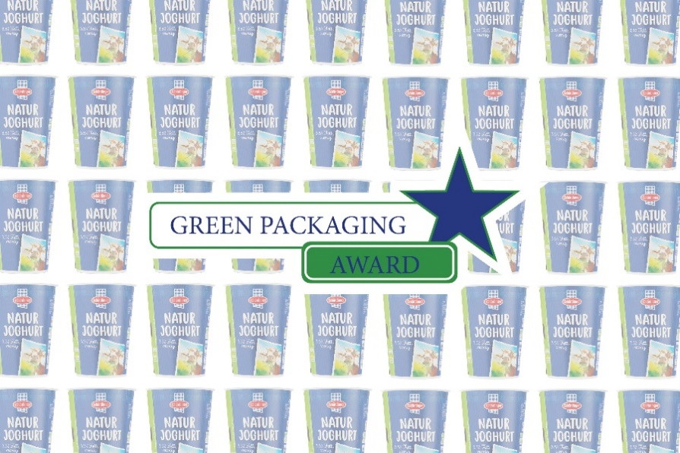

Caption: Once again, Greiner Packaging was awarded the Green Packaging Star Award and thus honored for its efforts in the field of sustainable packaging solutions. The innovation was introduced for the first time to the Austrian market by the dairy company Berglandmilch.

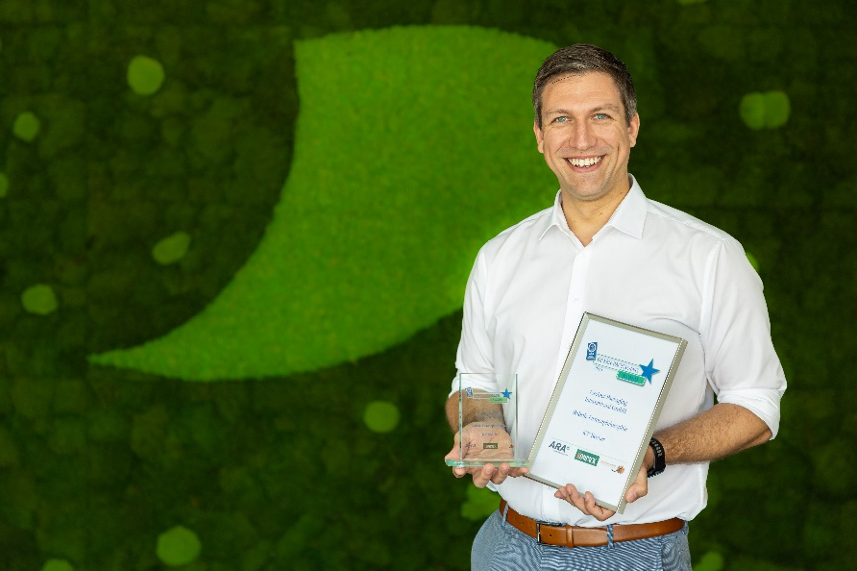

Caption: Fabian Grabner, Global Product Group Manager at Greiner Packaging is pleased about receiving the Green Packaging Star Award.

About Greiner Packaging
Greiner Packaging is a leading European manufacturer of plastic packaging in the food and nonfood sectors. The company has enjoyed a reputation for outstanding solutions expertise in the fields of development, design, production, and decoration for over 60 years. Greiner Packaging responds to the challenges of the market with two business units: Packaging and Assistec. While the Packaging unit focuses on innovative packaging solutions, the Assistec unit is dedicated to producing custom-made technical parts. Greiner Packaging employs a workforce of more than 5.000 at more than 30 locations in 19 countries around the world. In 2022, the company generated annual sales revenues of EUR 909 million (including joint ventures), which represents almost 40% of Greiner’s total sales.

Media contact for Greiner Packaging:
Charlotte Enzelsberger

Greiner Packaging International GmbH
Gewerbestraße 15, 4642 Sattledt, Austria
Mobile: +43 664 88218364
E-mail: c.enzelsberger@greiner-gpi.com

