OLMA: The first Czech company with self-separating K3® r100 packaging from Greiner Packaging

With its Carte d’Or and Cavalier brands, OLMA is launching the environmentally friendly K3® r100 packaging solution in the Czech Republic for the first time, making it even easier to recycle plastic cups and cardboard wraps.

Kremsmünster, Austria, September 2024. With its Carte d’Or and Cavalier brands, OLMA is well-known in the Czech retail sector for its dessert variations in the refrigerated section. The combinations of fresh and tangy sour cream and sweet fruit, chocolate, or caramel ingredients are a hit with young and old alike – and now their innovative packaging is also causing a stir. Since the spring, OLMA has been the first food manufacturer in the Czech Republic to pack its dessert variations in self-separating K3® r100 cups from Greiner Packaging.

With the K3® r100, the cardboard wrap and plastic packaging are separated from each other during the waste disposal process without human intervention. This means that achieving an excellent recyclability rate of up to 98% does not depend on proper separation by the end consumer: It happens completely independently even before it arrives at the recycling plant. The empty cup can be easily disposed of after the dessert has been enjoyed.
“We value Greiner Packaging as an innovative and reliable partner, and the new K3® r100 development impressed us right from the start. With our desserts, we not only rely on the best ingredients, but also on packaging that is second to none,” emphasizes Ing. Martin Krystián, CEO of OLMA.

The award-winning K3® r100
K3® r100 is Greiner Packaging’s latest innovation in cardboard-plastic combinations that have been tried and tested for many years: The materials separate themselves even before they reach the recycling plant’s near-infrared (NIR) sorting system. This makes detection, sorting, and recycling much more efficient. Before recycling, K3® r100 ensures that cardboard and plastic wind up in the correct material stream during the initial sorting process. The cup is also a real visual highlight and practical to handle.

The K3® r100 innovation was honored with the World Star Packaging Award in January. Greiner Packaging also received the Green Packaging Star Award from the Austrian magazine KOMPACK last October, after Berglandmilch became the first company in the country to introduce packaging made from the self-separating K3® r100.

Text & images:
Text document as well as images in high-resolution quality for download:
https://greinerpackaging.canto.de/b/QU2TL

Credit: Greiner Packaging

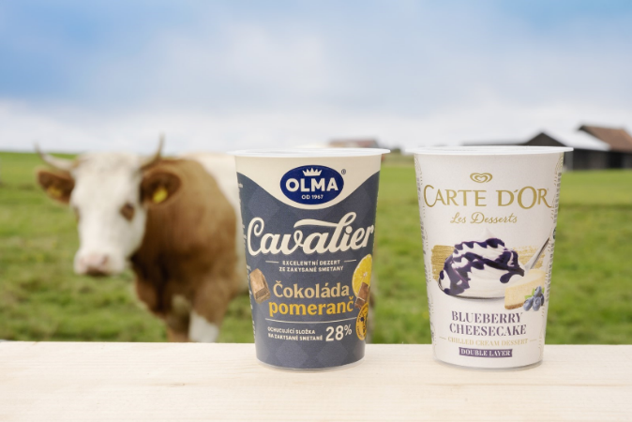
Image caption: OLMA is the first company in the Czech Republic to use the self-separating K3® r100 packaging solution from Greiner Packaging for its Carte d’Or and Cavalier food brands.
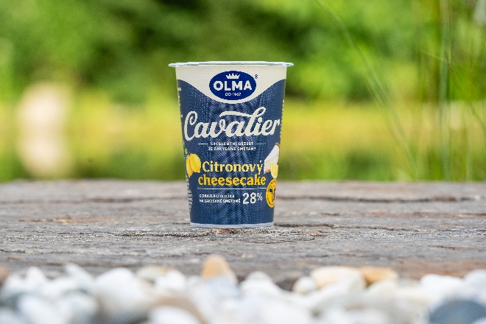Image caption: OLMA embraces sustainability with Greiner Packaging‘s innovative, high-quality K3® r100 cup. | 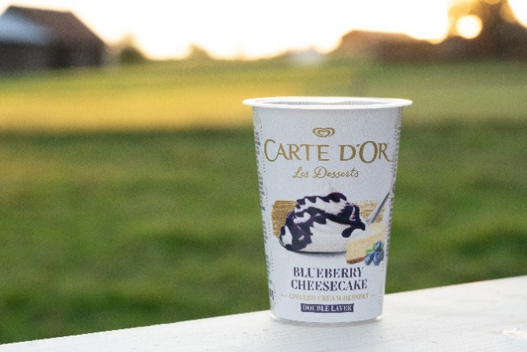Image caption: OLMA embraces sustainability with Greiner Packaging‘s innovative, high-quality K3® r100 cup.
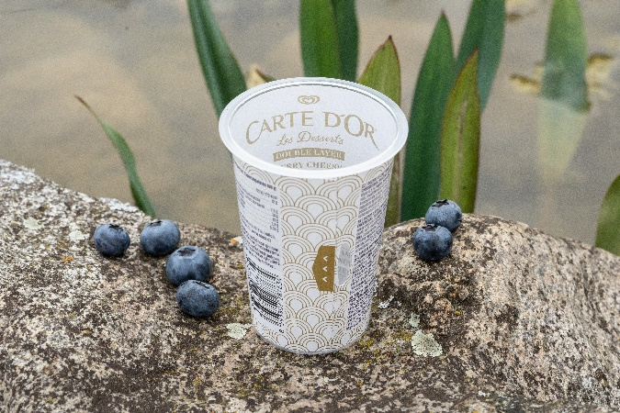Image caption: OLMA's Carte D'Or line utilizes the innovative K3® r100 cup with an inside print for enhanced consumer communication, and a tear tab for easy consumer separation. The cardboard wrap and plastic cup separate automatically during the waste collection process. | 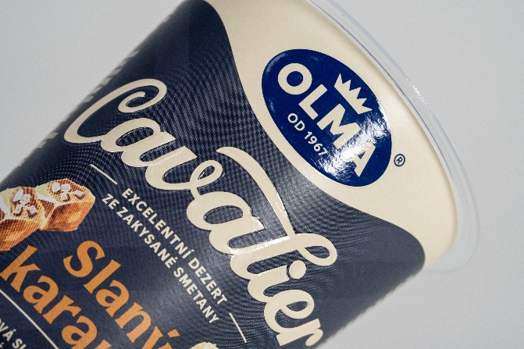Image caption: OLMA's Cavalier line stands out with its K3® r100 cup from Greiner Packaging, featuring a premium look and feel enhanced by an elegant embossing design option.

About Greiner Packaging
Greiner Packaging is one of the leading European manufacturers of plastic packaging in the food and non-food sector. For over 60 years, the company has stood for a high level of expertise in finding solutions in development, design, production, and decoration. Greiner Packaging meets the challenges of the market with two business units: Packaging and Assistec. While the former stands for innovative packaging solutions, the latter focuses on the production of customized technical parts. Greiner Packaging employs over 4,800 people at 30 locations in 19 countries worldwide. In 2023, the company achieved an annual turnover of 845 million euros (incl. joint ventures). This is almost 40% of Greiner’s total turnover.

Greiner Packaging Media Contact:
Peter Dobosz
Global Expert PR & Content Marketing

Greiner Packaging International GmbH
Gewerbestraße 15, 4642 Sattledt, Austria
Mobile: +43 664 4110735
E-mail: p.dobosz@greiner-gpi.com

