**Greiner Packaging Wins IMDA Award for Best Use of IML**

* **Award-Winning Packaging:** Greiner Packaging received the Best Use of IML – Traditional Aesthetic award at the 2024 IMDA competition for its innovative in-mold labeling (IML) solution.
* **Sustainability and Visual Appeal:** The IML technology delivers vibrant graphics, as well as enhanced durability and recyclability.
* **Versatile Application**: The award-winning cup is highly adaptable and can be applied across various product categories.

**Kremsmünster, Austria, October 2024.** The In-Mold Decorating Association (IMDA) awarded Greiner Packaging the "Best Use of IML – Traditional Aesthetic" award at its 2024 competition, recognizing the company's leading role in the in-mold labeling industry. Entries were evaluated based on criteria such as overall design, complexity, integration of the in-mold element, functionality, and degree of innovation in material and process usage. This award highlights Greiner’s commitment to innovative and sustainable packaging solutions.

**Award-Winning Innovation: In-Mold Labeling (IML) Technology**

The award-winning cup utilizes in-mold labeling (IML) technology, in which the label is fused directly into the container during molding. This offers several key advantages over traditional sleeved packaging:

* **Superior Visual Appeal:** IML provides vibrant, high-resolution graphics that stand out on the shelf, ensuring that products are visually striking and premium in their presentation.
* **Durability:** The label is embedded into the container, offering resistance to moisture, scratching, and wear, ensuring longevity throughout the product’s lifecycle.
* **Sustainability**: The use of mono-materials in IML packaging simplifies recycling by ensuring that both the container and label are made from the same material, reducing plastic waste, and contributing to a circular economy.

**Pioneering Sustainability and Innovation**

Greiner Packaging is dedicated to creating eco-conscious packaging solutions. Their IML technology minimizes the need for additional materials, such as glue or secondary labels, making the packaging more sustainable and enhancing its recyclability. By integrating this technology into the cup, the packaging expert ensured that consumers could enjoy their product while also making an environmentally responsible choice.

**A Versatile Packaging Solution for Multiple Markets**

IML technology is not only a game changer in terms of sustainability and design but also a versatile solution suitable for various product categories. Whether it’s dairy, dips, cheeses, or cereals, Greiner Packaging can help customers in these markets seamlessly launch products with IML packaging that enhances both brand presence and sustainability. The award-winning cup design showcases how Greiner can support their customers by delivering packaging solutions that meet the evolving demands of the market while staying committed to sustainability.

**About the IMDA Awards**

The IMDA Awards honor the best innovations in in-mold technology, celebrating companies that demonstrate excellence in sustainability, functionality, and design. Winning the Best Use of IML – Traditional Aesthetic award reinforces Greiner Packaging’s leadership in delivering high-performance solutions that meet the demands of today’s environmentally conscious consumers.

**Greiner Packaging at Pack Expo 2024**

Get a look at Greiner’s sustainable IML solutions and advanced technologies at Pack Expo 2024 in Chicago. Attendees will have the chance to explore how the packaging expert is setting new standards in packaging innovation. Meet Greiner from November 3-6 at booth W-22013. For more information, visit the [Pack Expo landing page](https://www.greiner-gpi.com/en/Greiner-Packaging/Fair-Events/2024/Pack-Expo-Chicago-2024).

**Text & images:**   
Text document as well as images in high-resolution quality for download:

<https://greinerpackaging.canto.de/b/Q3GSM>

**Credit:** Greiner Packaging

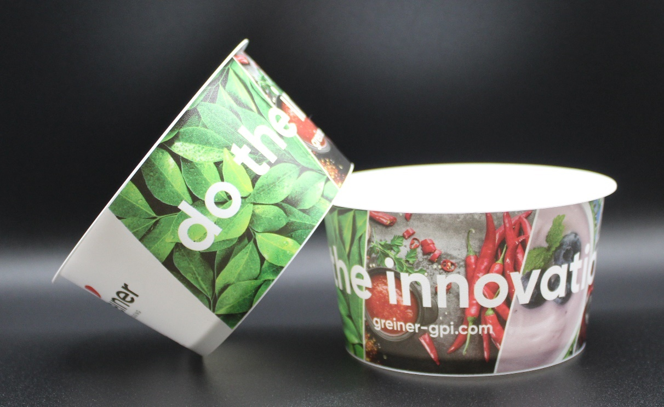

**Image caption:** Award-winning IML cup: a perfect blend of sustainability and visual appeal

**About Greiner Packaging**

Greiner Packaging is one of the leading European manufacturers of plastic packaging in the food and non-food sector. For over 60 years, the company has stood for a high level of expertise in finding solutions in development, design, production, and decoration. Greiner Packaging meets the challenges of the market with two business units: Packaging and Assistec. While the former stands for innovative packaging solutions, the latter focuses on the production of customized technical parts. Greiner Packaging employs over 4,800 people at 30 locations in 19 countries worldwide. In 2023, the company achieved an annual turnover of 845 million euros (incl. joint ventures). This is almost 40% of Greiner’s total turnover.

**Greiner Packaging Media Contact:**

Peter Dobosz   
Global Expert PR & Content Marketing

Greiner Packaging International GmbH      
Gewerbestraße 15, 4642 Sattledt, Austria     
Mobile: +43 664 4110735   
E-mail: [p.dobosz@greiner-gpi.com](mailto:p.dobosz@greiner-gpi.com)