**Greiner Packaging Joins the**

**Association of Plastic Recyclers**

**Pittston, January 29, 2025. Greiner Packaging is proud to announce its membership in the Association of Plastic Recyclers (APR), starting in 2025. This step reinforces the packaging expert’s commitment to advancing sustainable packaging and circular economy solutions in North America, a rapidly growing market for Greiner Packaging.**

With the increasing demand for sustainable packaging in the United States and across North America, Greiner Packaging is focused on aligning its portfolio with recycler expectations and achieving certifications for Design for Recyclability. These efforts address both national and state-level requirements, ensuring the company’s solutions remain at the forefront of the industry.

Greiner Packaging has long been dedicated to providing sustainable solutions, such as K3® packaging, products containing post-consumer recycled content (PCR), and reusable alternatives. By joining APR, the company enhances its ability to align its packaging with recyclability standards and ensure its solutions meet both national and state-specific requirements. For customers, this membership means added assurance that Greiner Packaging’s products are designed to perform optimally within the North American recycling infrastructure. Additionally, the collaboration with APR strengthens the company’s capacity to guide customers on how to improve recycling outcomes for consumers, contributing to a more effective circular economy.

“Joining APR allows us to collaborate closely with industry leaders, certify our existing products, and guide customers and consumers in recycling effectively,” says Jonas Kristensson, Sales Director at Greiner Packaging Pittston. “This partnership supports our mission for building a robust circular economy in the North American market.”

Through APR membership, Greiner Packaging also reinforces its role as a trusted partner for businesses navigating complex recycling regulations and sustainability demands. By fostering collaboration and innovation, the company helps its customers remain at the forefront of sustainable packaging solutions.

**About APR:**

The Association of Plastic Recyclers (APR) is a US-based international non-profit and the only North American organization focused exclusively on improving recycling for plastics. APR’s tools & resources help companies design packaging that can be recycled, support innovations that overcome existing recycling challenges, and encourage stable and reliable markets for post-consumer recycled content. Visit plasticsrecycling.org for more information.

**Text & images:**

Text document as well as images in high-resolution quality for download:

<https://greinerpackaging.canto.de/b/S62OE>

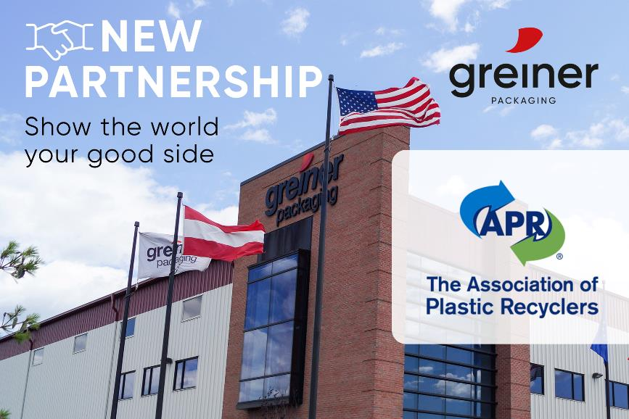

**Image caption:** Greiner Packaging becomes member of the Association of Plastic Recyclers (APR).

**Credit:** © Greiner Packaging

**About Greiner Packaging**

Greiner Packaging helps global food, beverage and household brands stand out sustainably with plastic packaging solutions that don’t compromise on quality or feel. For more than 60 years, we’ve helped customers all over the world make an impact on the shelf - and the planet - with packaging solutions born from lightweight, sustainable materials and cutting-edge European design and innovation. This is best exemplified by our award-winning K3® - a revolutionary cardboard-plastic cup. With expert design and prototyping services, a wide range of production, material and decoration technologies, and 30+ locations in 19 countries, Greiner Packaging is the ideal partner for bold brands who want to show the world their good side.

To learn more about Greiner & our packaging solutions, visit greiner-gpi.com.

**Greiner Packaging Media Contact:**

Peter Dobosz   
Global Expert PR & Content Marketing

Greiner Packaging International GmbH      
Gewerbestraße 15, 4642 Sattledt, Austria     
Mobile: +43 664 4110735   
E-mail: [p.dobosz@greiner-gpi.com](mailto:p.dobosz@greiner-gpi.com   )