Greiner Assistec Receives Supplier of the Year Award

As a global multi-technology company, 3M relies on smooth cooperation with partners all over the world. Greiner Assistec has also been a valued supplier for a number of years, and the plastics specialist has now been presented with the 3M EMEA Supplier of the Year Award for its services in 2018.

Kremsmünster, Austria, July 2019. With its extensive technological expertise and innovative services, Greiner Assistec is often more than just a supplier to its customers. As a long-term partner, the company is on hand to assist its customers from the product development stage, and helps them to achieve the desired product success with perfectly tailored processes. The customized solutions are also appreciated by 3M: “We regard Greiner Assistec as a long-standing and reliable partner who always proactively approaches us and never fails to impress us with a very high level of service. In 2018, we worked with Greiner Assistec to successfully realize a whole host of projects, which also fully met our expectations in terms of value for money,” says Grzegorz Macikowski, Sourcing Manager at 3M, explaining the jury’s decision. Every year, the company recognizes especially trustworthy suppliers who meet or even exceed its expectations by presenting them with the Supplier of the Year Award. The award is presented at the headquarters of the subsidiary 3M EMEA in Langenthal, Switzerland. This is where procurement and logistics operations are organized for 3M products destined for Europe, the Middle East, and Africa.

“We are delighted with this award because it confirms the successful strategy adopted by Greiner Assistec in recent years,” stresses Krzysztof Litwiniec, Global Key Account Manager at Greiner Assistec. “We see ourselves as a competent partner to our customers by developing individual solutions using our technological expertise. It is always nice when our work is appreciated and recognized with an award.”

About Greiner Packaging & Greiner Assistec
Greiner Packaging is one of Europe’s leading manufacturers of plastic packaging in the food and nonfood sectors. For almost 60 years, the company has been committed to using its high level of expertise to provide development, design, production, and decoration solutions. Greiner Packaging responds to the challenges of the market with two business units: Packaging and Assistec. While the former focuses on innovative packaging solutions, the latter concentrates on the production of customized technical parts. Greiner Packaging employs around 4,800 people across more than 30 locations in 19 countries worldwide. In 2018 the company generated an annual turnover of 673 million euros (including joint ventures). This represents more than a third of Greiner’s total turnover.

Text and image:

Text document and images available to download in high resolution:
https://mam.greiner.at/pinaccess/showpin.do?pinCode=8Db5XpL1eELT

Images may be used free of charge, credit: Greiner Packaging

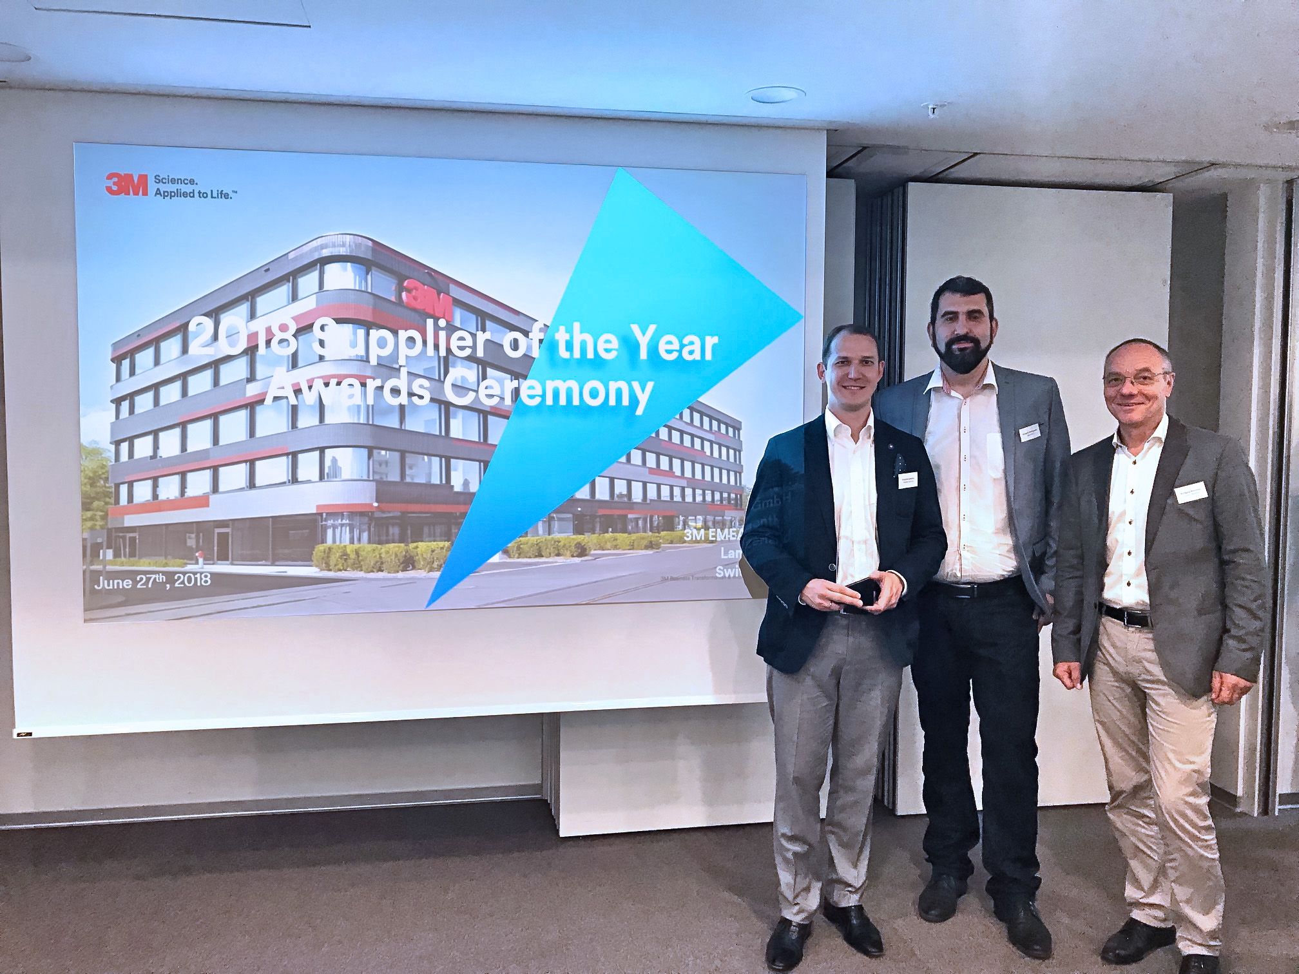

Caption: Krzysztof Litwiniec (Global Key Account Manager at Greiner Assistec), Grzegorz Macikowski (Sourcing Manager at 3M) and Wolfgang Rotschopf (Sales Director at Greiner Assistec) at the award ceremony at 3M’s Swiss headquarters in Langenthal.

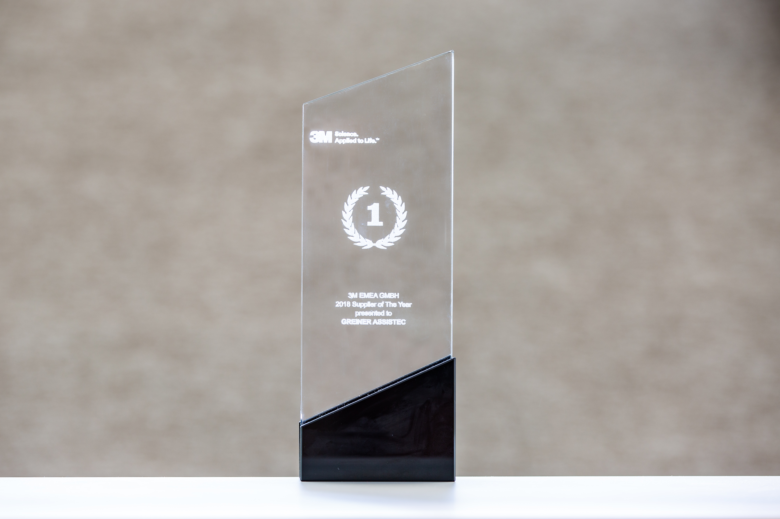

Caption: The “2018 Supplier of The Year” Award which was awarded to Greiner Assistec.

Please send your enquiries to:
Carina Maurer I Text, Conception, and PR
SPS MARKETING GmbH | B 2 Businessclass | Linz, Stuttgart
Jaxstrasse 2–4, 4020 Linz, Austria
Tel. +43-732-6050-3829
E-mail: c.maurer@sps-marketing.com
www.sps-marketing.com

